|  |  |
| --- | --- |
|  | **ATTENDANCE MODULE**  <script src="<https://ajax.googleapis.com/ajax/libs/jquery/2.1.1/jquery.min.js>"></script> |
|  | <form action="attendence.php"> |
|  | <style> |
|  | input[type=text], select { |
|  | width: 100%; |
|  | padding: 12px 20px; |
|  | margin: 8px 0; |
|  | display: inline-block; |
|  | border: 1px solid #ccc; |
|  | border-radius: 4px; |
|  | box-sizing: border-box; |
|  | } |
|  |  |
|  | input[type=submit] { |
|  | width: 100%; |
|  | background-color: #4CAF50; |
|  | color: white; |
|  | padding: 14px 20px; |
|  | margin: 8px 0; |
|  | border: none; |
|  | border-radius: 4px; |
|  | cursor: pointer; |
|  | } |
|  |  |
|  | input[type=submit]:hover { |
|  | background-color: #45a049; |
|  | } |
|  |  |
|  | div { |
|  | border-radius: 5px; |
|  | background-color: #f2f2f2; |
|  | padding: 20px; |
|  | } |
|  | </style> |
|  | <select id="program_ch"> |
|  | <option>select</option> |
|  | <option value="MCA">MCA</option> |
|  | <option value="BCA">BCA</option> |
|  | </select> |
|  | <br/> |
|  | <select id="course_ch" name='course_ch'> |
|  | <option value="">select </option> |
|  |  |
|  | </select> |
|  | <br/> |
|  | <input type="submit" value="Submit"> |
|  |  |
|  | </form> |
|  | <script> |
|  | $('#program_ch').on('change', function () { |
|  | // alert(this.value); |
|  | var id = this.value; |
|  | $.ajax({ |
|  | type: 'POST', |
|  | url: 'courses.php', |
|  | data: { |
|  | 'id': id |
|  | }, |
|  | dataType: 'json', // what type of data do we expect back from the server |
|  | encode: true, |
|  | success: function (data) { |
|  | // alert(data); |
|  | console.log(data.length) |
|  | console.log(data) |
|  |  |
|  | // the next thing you want to do |
|  | var course_ch = $('#course_ch'); |
|  | course_ch.empty(); |
|  | // $('#city').empty(); |
|  | for (var i = 0; i < data.length; i++) { |
|  | course_ch.append('<option id=' + data[i].course_code + ' value=' + data[i].course_code + '>' + data[i].course_code + '</option>'); |
|  | } |
|  |  |
|  | //manually trigger a change event for the contry so that the change handler will get triggered |
|  | course_ch.change(); |
|  | } |
|  | }); |
|  |  |
|  | }); |
|  | </script>  OUTPUT |

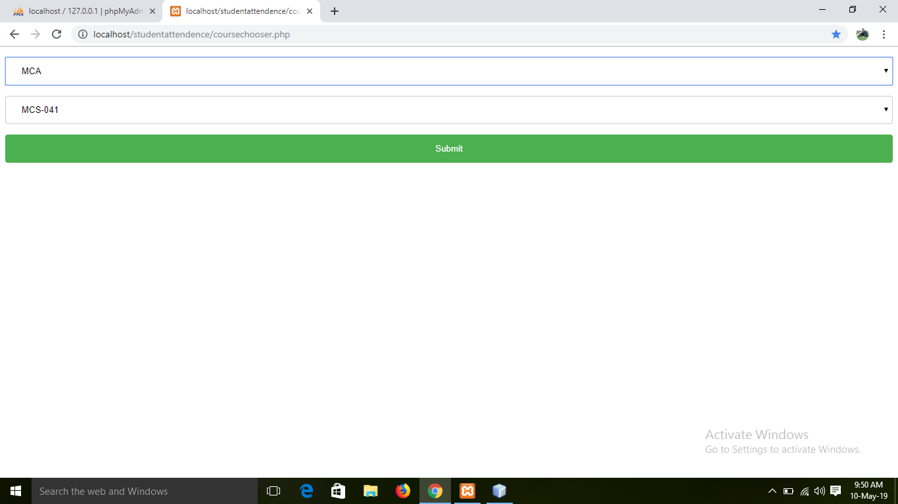

**REGISTER TABLE :**

|  |  |
| --- | --- |
|  | <!DOCTYPE html> |
|  |  |
|  | <html> |
|  | <head> |
|  | <meta charset="UTF-8"> |
|  | <title></title> |
|  | </head> |
|  | <script src="<https://ajax.googleapis.com/ajax/libs/jquery/3.4.0/jquery.min.js>"></script> |
|  | <body> |
|  |  |
|  | <style> |
|  | table, th, td { |
|  | border: 1px solid black; |
|  | border-collapse: collapse; |
|  | } |
|  | th, td { |
|  | padding: 5px; |
|  | } |
|  | th { |
|  | text-align: left; |
|  | } |
|  | </style> |
|  | </head> |
|  | <body> |
|  |  |
|  | <h2>Student Attendence Register</h2> |
|  | <input type='date' name='classday' id='classday' /> |
|  | <table style="width:100%"> |
|  | <tr> |
|  | <th>S.NO</th> |
|  | <th>ENROLLMENT NUMBER</th> |
|  | <th>NAME</th> |
|  | <th>TOTAL CLASS</th> |
|  | <th>PRESENT</th> |
|  | <th>ABSENT</th> |
|  | <th>DATE</th> |
|  | <th>TIME</th> |
|  | <th>PRESENT CLASS</th> |
|  | </tr> |
|  |  |
|  | MCS-041<tr> |
|  | <input type='hidden' name='enrollment' id='enrollment' value='173564460'/> |
|  | <td>1</td> |
|  | <td>173564460</td> |
|  | <td>SARABONI SINHA</td> |
|  | <td>12</td> |
|  | <td><input type='checkbox' id='173564460_p' name='173564460_p' /></td> |
|  | <td><input type='checkbox' id='173564460_a' name='173564460_a' checked/></td><td></td> |
|  | <td></td> |
|  | <td><input type='text' id='173564460_ta' name='173564460_ta' value='0' /></td> |
|  | </tr><tr> |
|  | <input type='hidden' name='enrollment' id='enrollment' value='173564943'/> |
|  | <td>2</td> |
|  | <td>173564943</td> |
|  | <td>KHUSHI KUMARI</td> |
|  | <td>12</td> |
|  | <td><input type='checkbox' id='173564943_p' name='173564943_p' /></td> |
|  | <td><input type='checkbox' id='173564943_a' name='173564943_a' checked/></td><td></td> |
|  | <td></td> |
|  | <td><input type='text' id='173564943_ta' name='173564943_ta' value='0' /></td> |
|  | </tr><tr> |
|  | <input type='hidden' name='enrollment' id='enrollment' value='173565107'/> |
|  | <td>3</td> |
|  | <td>173565107</td> |
|  | <td>SANA KHAN</td> |
|  | <td>12</td> |
|  | <td><input type='checkbox' id='173565107_p' name='173565107_p' /></td> |
|  | <td><input type='checkbox' id='173565107_a' name='173565107_a' checked/></td><td></td> |
|  | <td></td> |
|  | <td><input type='text' id='173565107_ta' name='173565107_ta' value='0' /></td> |
|  | </tr><tr> |
|  | <input type='hidden' name='enrollment' id='enrollment' value='173565447'/> |
|  | <td>4</td> |
|  | <td>173565447</td> |
|  | <td>K K UMA</td> |
|  | <td>12</td> |
|  | <td><input type='checkbox' id='173565447_p' name='173565447_p' /></td> |
|  | <td><input type='checkbox' id='173565447_a' name='173565447_a' checked/></td><td></td> |
|  | <td></td> |
|  | <td><input type='text' id='173565447_ta' name='173565447_ta' value='0' /></td> |
|  | </tr><tr> |
|  | <input type='hidden' name='enrollment' id='enrollment' value='173565461'/> |
|  | <td>5</td> |
|  | <td>173565461</td> |
|  | <td>SANTOSHI MATHO</td> |
|  | <td>12</td> |
|  | <td><input type='checkbox' id='173565461_p' name='173565461_p' /></td> |
|  | <td><input type='checkbox' id='173565461_a' name='173565461_a' checked/></td><td></td> |
|  | <td></td> |
|  | <td><input type='text' id='173565461_ta' name='173565461_ta' value='0' /></td> |
|  | </tr><tr> |
|  | <input type='hidden' name='enrollment' id='enrollment' value='173565620'/> |
|  | <td>6</td> |
|  | <td>173565620</td> |
|  | <td>SNEHA KARAMAKAR</td> |
|  | <td>12</td> |
|  | <td><input type='checkbox' id='173565620_p' name='173565620_p' /></td> |
|  | <td><input type='checkbox' id='173565620_a' name='173565620_a' checked/></td><td></td> |
|  | <td></td> |
|  | <td><input type='text' id='173565620_ta' name='173565620_ta' value='0' /></td> |
|  | </tr><tr> |
|  | <input type='hidden' name='enrollment' id='enrollment' value='173565651'/> |
|  | <td>7</td> |
|  | <td>173565651</td> |
|  | <td>RAJESH PRADHAN</td> |
|  | <td>12</td> |
|  | <td><input type='checkbox' id='173565651_p' name='173565651_p' /></td> |
|  | <td><input type='checkbox' id='173565651_a' name='173565651_a' checked/></td><td></td> |
|  | <td></td> |
|  | <td><input type='text' id='173565651_ta' name='173565651_ta' value='0' /></td> |
|  | </tr><tr> |
|  | <input type='hidden' name='enrollment' id='enrollment' value='173565859'/> |
|  | <td>8</td> |
|  | <td>173565859</td> |
|  | <td>MADHUMITA JHA</td> |
|  | <td>12</td> |
|  | <td><input type='checkbox' id='173565859_p' name='173565859_p' /></td> |
|  | <td><input type='checkbox' id='173565859_a' name='173565859_a' checked/></td><td></td> |
|  | <td></td> |
|  | <td><input type='text' id='173565859_ta' name='173565859_ta' value='0' /></td> |
|  | </tr><tr> |
|  | <input type='hidden' name='enrollment' id='enrollment' value='173565913'/> |
|  | <td>9</td> |
|  | <td>173565913</td> |
|  | <td>ANTRA SARKAR</td> |
|  | <td>12</td> |
|  | <td><input type='checkbox' id='173565913_p' name='173565913_p' /></td> |
|  | <td><input type='checkbox' id='173565913_a' name='173565913_a' checked/></td><td></td> |
|  | <td></td> |
|  | <td><input type='text' id='173565913_ta' name='173565913_ta' value='0' /></td> |
|  | </tr><tr> |
|  | <input type='hidden' name='enrollment' id='enrollment' value='173857969'/> |
|  | <td>10</td> |
|  | <td>173857969</td> |
|  | <td>NISHA KUMARI</td> |
|  | <td>12</td> |
|  | <td><input type='checkbox' id='173857969_p' name='173857969_p' /></td> |
|  | <td><input type='checkbox' id='173857969_a' name='173857969_a' checked/></td><td></td> |
|  | <td></td> |
|  | <td><input type='text' id='173857969_ta' name='173857969_ta' value='0' /></td> |
|  | </tr><tr> |
|  | <input type='hidden' name='enrollment' id='enrollment' value='173861066'/> |
|  | <td>11</td> |
|  | <td>173861066</td> |
|  | <td>VIKASH KUMAR</td> |
|  | <td>12</td> |
|  | <td><input type='checkbox' id='173861066_p' name='173861066_p' /></td> |
|  | <td><input type='checkbox' id='173861066_a' name='173861066_a' checked/></td><td></td> |
|  | <td></td> |
|  | <td><input type='text' id='173861066_ta' name='173861066_ta' value='0' /></td> |
|  | </tr><tr> |
|  | <input type='hidden' name='enrollment' id='enrollment' value='177419818'/> |
|  | <td>12</td> |
|  | <td>177419818</td> |
|  | <td>MUKTA DUBEY</td> |
|  | <td>12</td> |
|  | <td><input type='checkbox' id='177419818_p' name='177419818_p' /></td> |
|  | <td><input type='checkbox' id='177419818_a' name='177419818_a' checked/></td><td></td> |
|  | <td></td> |
|  | <td><input type='text' id='177419818_ta' name='177419818_ta' value='0' /></td> |
|  | </tr><tr> |
|  | <input type='hidden' name='enrollment' id='enrollment' value='178765991'/> |
|  | <td>13</td> |
|  | <td>178765991</td> |
|  | <td>SAMA TABASSUM</td> |
|  | <td>12</td> |
|  | <td><input type='checkbox' id='178765991_p' name='178765991_p' /></td> |
|  | <td><input type='checkbox' id='178765991_a' name='178765991_a' checked/></td><td></td> |
|  | <td></td> |
|  | <td><input type='text' id='178765991_ta' name='178765991_ta' value='0' /></td> |
|  | </tr> </table> |
|  | </body> |
|  | </html> |
|  |  |
|  |  |
|  |  |
|  |  |
|  | <script> |
|  | $(document).ready(function(){ |
|  |  |
|  | $('#173564460_p').click(function(){ |
|  | var new_val = parseInt($('#173564460_ta').val(),10) + 1; |
|  | $('#173564460_ta').val(new_val); |
|  |  |
|  | $('#173564460_a').prop('checked', false); |
|  | }); |
|  |  |
|  | $('#173564460_a').click(function(){ |
|  |  |
|  | var new_val = parseInt($('#173564460_ta').val(),10) - 1; |
|  | $('#173564460_ta').val(new_val); |
|  |  |
|  | $('#173564460_p').prop('checked', false); |
|  | }); |
|  |  |
|  | $('#173564943_p').click(function(){ |
|  | var new_val = parseInt($('#173564943_ta').val(),10) + 1; |
|  | $('#173564943_ta').val(new_val); |
|  |  |
|  | $('#173564943_a').prop('checked', false); |
|  | }); |
|  |  |
|  | $('#173564943_a').click(function(){ |
|  |  |
|  | var new_val = parseInt($('#173564943_ta').val(),10) - 1; |
|  | $('#173564943_ta').val(new_val); |
|  |  |
|  | $('#173564943_p').prop('checked', false); |
|  | }); |
|  |  |
|  | $('#173565107_p').click(function(){ |
|  | var new_val = parseInt($('#173565107_ta').val(),10) + 1; |
|  | $('#173565107_ta').val(new_val); |
|  |  |
|  | $('#173565107_a').prop('checked', false); |
|  | }); |
|  |  |
|  | $('#173565107_a').click(function(){ |
|  |  |
|  | var new_val = parseInt($('#173565107_ta').val(),10) - 1; |
|  | $('#173565107_ta').val(new_val); |
|  |  |
|  | $('#173565107_p').prop('checked', false); |
|  | }); |
|  |  |
|  | $('#173565447_p').click(function(){ |
|  | var new_val = parseInt($('#173565447_ta').val(),10) + 1; |
|  | $('#173565447_ta').val(new_val); |
|  |  |
|  | $('#173565447_a').prop('checked', false); |
|  | }); |
|  |  |
|  | $('#173565447_a').click(function(){ |
|  |  |
|  | var new_val = parseInt($('#173565447_ta').val(),10) - 1; |
|  | $('#173565447_ta').val(new_val); |
|  |  |
|  | $('#173565447_p').prop('checked', false); |
|  | }); |
|  |  |
|  | $('#173565461_p').click(function(){ |
|  | var new_val = parseInt($('#173565461_ta').val(),10) + 1; |
|  | $('#173565461_ta').val(new_val); |
|  |  |
|  | $('#173565461_a').prop('checked', false); |
|  | }); |
|  |  |
|  | $('#173565461_a').click(function(){ |
|  |  |
|  | var new_val = parseInt($('#173565461_ta').val(),10) - 1; |
|  | $('#173565461_ta').val(new_val); |
|  |  |
|  | $('#173565461_p').prop('checked', false); |
|  | }); |
|  |  |
|  | $('#173565620_p').click(function(){ |
|  | var new_val = parseInt($('#173565620_ta').val(),10) + 1; |
|  | $('#173565620_ta').val(new_val); |
|  |  |
|  | $('#173565620_a').prop('checked', false); |
|  | }); |
|  |  |
|  | $('#173565620_a').click(function(){ |
|  |  |
|  | var new_val = parseInt($('#173565620_ta').val(),10) - 1; |
|  | $('#173565620_ta').val(new_val); |
|  |  |
|  | $('#173565620_p').prop('checked', false); |
|  | }); |
|  |  |
|  | $('#173565651_p').click(function(){ |
|  | var new_val = parseInt($('#173565651_ta').val(),10) + 1; |
|  | $('#173565651_ta').val(new_val); |
|  |  |
|  | $('#173565651_a').prop('checked', false); |
|  | }); |
|  |  |
|  | $('#173565651_a').click(function(){ |
|  |  |
|  | var new_val = parseInt($('#173565651_ta').val(),10) - 1; |
|  | $('#173565651_ta').val(new_val); |
|  |  |
|  | $('#173565651_p').prop('checked', false); |
|  | }); |
|  |  |
|  | $('#173565859_p').click(function(){ |
|  | var new_val = parseInt($('#173565859_ta').val(),10) + 1; |
|  | $('#173565859_ta').val(new_val); |
|  |  |
|  | $('#173565859_a').prop('checked', false); |
|  | }); |
|  |  |
|  | $('#173565859_a').click(function(){ |
|  |  |
|  | var new_val = parseInt($('#173565859_ta').val(),10) - 1; |
|  | $('#173565859_ta').val(new_val); |
|  |  |
|  | $('#173565859_p').prop('checked', false); |
|  | }); |
|  |  |
|  | $('#173565913_p').click(function(){ |
|  | var new_val = parseInt($('#173565913_ta').val(),10) + 1; |
|  | $('#173565913_ta').val(new_val); |
|  |  |
|  | $('#173565913_a').prop('checked', false); |
|  | }); |
|  |  |
|  | $('#173565913_a').click(function(){ |
|  |  |
|  | var new_val = parseInt($('#173565913_ta').val(),10) - 1; |
|  | $('#173565913_ta').val(new_val); |
|  |  |
|  | $('#173565913_p').prop('checked', false); |
|  | }); |
|  |  |
|  | $('#173857969_p').click(function(){ |
|  | var new_val = parseInt($('#173857969_ta').val(),10) + 1; |
|  | $('#173857969_ta').val(new_val); |
|  |  |
|  | $('#173857969_a').prop('checked', false); |
|  | }); |
|  |  |
|  | $('#173857969_a').click(function(){ |
|  |  |
|  | var new_val = parseInt($('#173857969_ta').val(),10) - 1; |
|  | $('#173857969_ta').val(new_val); |
|  |  |
|  | $('#173857969_p').prop('checked', false); |
|  | }); |
|  |  |
|  | $('#173861066_p').click(function(){ |
|  | var new_val = parseInt($('#173861066_ta').val(),10) + 1; |
|  | $('#173861066_ta').val(new_val); |
|  |  |
|  | $('#173861066_a').prop('checked', false); |
|  | }); |
|  |  |
|  | $('#173861066_a').click(function(){ |
|  |  |
|  | var new_val = parseInt($('#173861066_ta').val(),10) - 1; |
|  | $('#173861066_ta').val(new_val); |
|  |  |
|  | $('#173861066_p').prop('checked', false); |
|  | }); |
|  |  |
|  | $('#177419818_p').click(function(){ |
|  | var new_val = parseInt($('#177419818_ta').val(),10) + 1; |
|  | $('#177419818_ta').val(new_val); |
|  |  |
|  | $('#177419818_a').prop('checked', false); |
|  | }); |
|  |  |
|  | $('#177419818_a').click(function(){ |
|  |  |
|  | var new_val = parseInt($('#177419818_ta').val(),10) - 1; |
|  | $('#177419818_ta').val(new_val); |
|  |  |
|  | $('#177419818_p').prop('checked', false); |
|  | }); |
|  |  |
|  | $('#178765991_p').click(function(){ |
|  | var new_val = parseInt($('#178765991_ta').val(),10) + 1; |
|  | $('#178765991_ta').val(new_val); |
|  |  |
|  | $('#178765991_a').prop('checked', false); |
|  | }); |
|  |  |
|  | $('#178765991_a').click(function(){ |
|  |  |
|  | var new_val = parseInt($('#178765991_ta').val(),10) - 1; |
|  | $('#178765991_ta').val(new_val); |
|  |  |
|  | $('#178765991_p').prop('checked', false); |
|  | }); |
|  |  |
|  |  |
|  | }); |
|  | </script> |

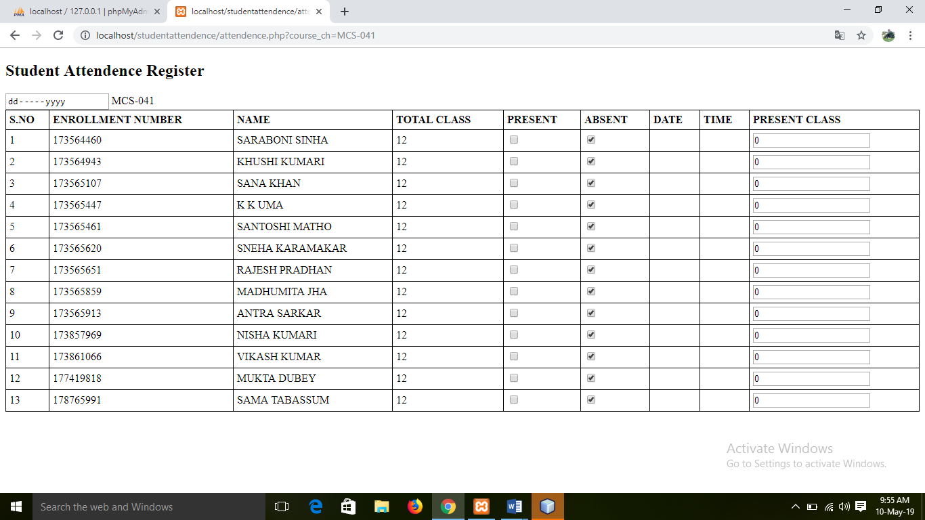

**REGISTER TABLE:**

|  |  |
| --- | --- |
|  | <!DOCTYPE html> |
|  |  |
|  | <html> |
|  | <head> |
|  | <meta charset="UTF-8"> |
|  | <title></title> |
|  | </head> |
|  | <script src="<https://ajax.googleapis.com/ajax/libs/jquery/3.4.0/jquery.min.js>"></script> |
|  | <body> |
|  |  |
|  | <style> |
|  | table, th, td { |
|  | border: 1px solid black; |
|  | border-collapse: collapse; |
|  | } |
|  | th, td { |
|  | padding: 5px; |
|  | } |
|  | th { |
|  | text-align: left; |
|  | } |
|  | </style> |
|  | </head> |
|  | <body> |
|  |  |
|  | <h2>Student Attendence Register</h2> |
|  | <input type='date' name='classday' id='classday' /> |
|  | <table style="width:100%"> |
|  | <tr> |
|  | <th>S.NO</th> |
|  | <th>ENROLLMENT NUMBER</th> |
|  | <th>NAME</th> |
|  | <th>TOTAL CLASS</th> |
|  | <th>PRESENT</th> |
|  | <th>ABSENT</th> |
|  | <th>DATE</th> |
|  | <th>TIME</th> |
|  | <th>PRESENT CLASS</th> |
|  | </tr> |
|  |  |
|  | MCS-041<tr> |
|  | <input type='hidden' name='enrollment' id='enrollment' value='173564460'/> |
|  | <td>1</td> |
|  | <td>173564460</td> |
|  | <td>SARABONI SINHA</td> |
|  | <td>12</td> |
|  | <td><input type='checkbox' id='173564460_p' name='173564460_p' /></td> |
|  | <td><input type='checkbox' id='173564460_a' name='173564460_a' checked/></td><td></td> |
|  | <td></td> |
|  | <td><input type='text' id='173564460_ta' name='173564460_ta' value='0' /></td> |
|  | </tr><tr> |
|  | <input type='hidden' name='enrollment' id='enrollment' value='173564943'/> |
|  | <td>2</td> |
|  | <td>173564943</td> |
|  | <td>KHUSHI KUMARI</td> |
|  | <td>12</td> |
|  | <td><input type='checkbox' id='173564943_p' name='173564943_p' /></td> |
|  | <td><input type='checkbox' id='173564943_a' name='173564943_a' checked/></td><td></td> |
|  | <td></td> |
|  | <td><input type='text' id='173564943_ta' name='173564943_ta' value='0' /></td> |
|  | </tr><tr> |
|  | <input type='hidden' name='enrollment' id='enrollment' value='173565107'/> |
|  | <td>3</td> |
|  | <td>173565107</td> |
|  | <td>SANA KHAN</td> |
|  | <td>12</td> |
|  | <td><input type='checkbox' id='173565107_p' name='173565107_p' /></td> |
|  | <td><input type='checkbox' id='173565107_a' name='173565107_a' checked/></td><td></td> |
|  | <td></td> |
|  | <td><input type='text' id='173565107_ta' name='173565107_ta' value='0' /></td> |
|  | </tr><tr> |
|  | <input type='hidden' name='enrollment' id='enrollment' value='173565447'/> |
|  | <td>4</td> |
|  | <td>173565447</td> |
|  | <td>K K UMA</td> |
|  | <td>12</td> |
|  | <td><input type='checkbox' id='173565447_p' name='173565447_p' /></td> |
|  | <td><input type='checkbox' id='173565447_a' name='173565447_a' checked/></td><td></td> |
|  | <td></td> |
|  | <td><input type='text' id='173565447_ta' name='173565447_ta' value='0' /></td> |
|  | </tr><tr> |
|  | <input type='hidden' name='enrollment' id='enrollment' value='173565461'/> |
|  | <td>5</td> |
|  | <td>173565461</td> |
|  | <td>SANTOSHI MATHO</td> |
|  | <td>12</td> |
|  | <td><input type='checkbox' id='173565461_p' name='173565461_p' /></td> |
|  | <td><input type='checkbox' id='173565461_a' name='173565461_a' checked/></td><td></td> |
|  | <td></td> |
|  | <td><input type='text' id='173565461_ta' name='173565461_ta' value='0' /></td> |
|  | </tr><tr> |
|  | <input type='hidden' name='enrollment' id='enrollment' value='173565620'/> |
|  | <td>6</td> |
|  | <td>173565620</td> |
|  | <td>SNEHA KARAMAKAR</td> |
|  | <td>12</td> |
|  | <td><input type='checkbox' id='173565620_p' name='173565620_p' /></td> |
|  | <td><input type='checkbox' id='173565620_a' name='173565620_a' checked/></td><td></td> |
|  | <td></td> |
|  | <td><input type='text' id='173565620_ta' name='173565620_ta' value='0' /></td> |
|  | </tr><tr> |
|  | <input type='hidden' name='enrollment' id='enrollment' value='173565651'/> |
|  | <td>7</td> |
|  | <td>173565651</td> |
|  | <td>RAJESH PRADHAN</td> |
|  | <td>12</td> |
|  | <td><input type='checkbox' id='173565651_p' name='173565651_p' /></td> |
|  | <td><input type='checkbox' id='173565651_a' name='173565651_a' checked/></td><td></td> |
|  | <td></td> |
|  | <td><input type='text' id='173565651_ta' name='173565651_ta' value='0' /></td> |
|  | </tr><tr> |
|  | <input type='hidden' name='enrollment' id='enrollment' value='173565859'/> |
|  | <td>8</td> |
|  | <td>173565859</td> |
|  | <td>MADHUMITA JHA</td> |
|  | <td>12</td> |
|  | <td><input type='checkbox' id='173565859_p' name='173565859_p' /></td> |
|  | <td><input type='checkbox' id='173565859_a' name='173565859_a' checked/></td><td></td> |
|  | <td></td> |
|  | <td><input type='text' id='173565859_ta' name='173565859_ta' value='0' /></td> |
|  | </tr><tr> |
|  | <input type='hidden' name='enrollment' id='enrollment' value='173565913'/> |
|  | <td>9</td> |
|  | <td>173565913</td> |
|  | <td>ANTRA SARKAR</td> |
|  | <td>12</td> |
|  | <td><input type='checkbox' id='173565913_p' name='173565913_p' /></td> |
|  | <td><input type='checkbox' id='173565913_a' name='173565913_a' checked/></td><td></td> |
|  | <td></td> |
|  | <td><input type='text' id='173565913_ta' name='173565913_ta' value='0' /></td> |
|  | </tr><tr> |
|  | <input type='hidden' name='enrollment' id='enrollment' value='173857969'/> |
|  | <td>10</td> |
|  | <td>173857969</td> |
|  | <td>NISHA KUMARI</td> |
|  | <td>12</td> |
|  | <td><input type='checkbox' id='173857969_p' name='173857969_p' /></td> |
|  | <td><input type='checkbox' id='173857969_a' name='173857969_a' checked/></td><td></td> |
|  | <td></td> |
|  | <td><input type='text' id='173857969_ta' name='173857969_ta' value='0' /></td> |
|  | </tr><tr> |
|  | <input type='hidden' name='enrollment' id='enrollment' value='173861066'/> |
|  | <td>11</td> |
|  | <td>173861066</td> |
|  | <td>VIKASH KUMAR</td> |
|  | <td>12</td> |
|  | <td><input type='checkbox' id='173861066_p' name='173861066_p' /></td> |
|  | <td><input type='checkbox' id='173861066_a' name='173861066_a' checked/></td><td></td> |
|  | <td></td> |
|  | <td><input type='text' id='173861066_ta' name='173861066_ta' value='0' /></td> |
|  | </tr><tr> |
|  | <input type='hidden' name='enrollment' id='enrollment' value='177419818'/> |
|  | <td>12</td> |
|  | <td>177419818</td> |
|  | <td>MUKTA DUBEY</td> |
|  | <td>12</td> |
|  | <td><input type='checkbox' id='177419818_p' name='177419818_p' /></td> |
|  | <td><input type='checkbox' id='177419818_a' name='177419818_a' checked/></td><td></td> |
|  | <td></td> |
|  | <td><input type='text' id='177419818_ta' name='177419818_ta' value='0' /></td> |
|  | </tr><tr> |
|  | <input type='hidden' name='enrollment' id='enrollment' value='178765991'/> |
|  | <td>13</td> |
|  | <td>178765991</td> |
|  | <td>SAMA TABASSUM</td> |
|  | <td>12</td> |
|  | <td><input type='checkbox' id='178765991_p' name='178765991_p' /></td> |
|  | <td><input type='checkbox' id='178765991_a' name='178765991_a' checked/></td><td></td> |
|  | <td></td> |
|  | <td><input type='text' id='178765991_ta' name='178765991_ta' value='0' /></td> |
|  | </tr> </table> |
|  | </body> |
|  | </html> |
|  |  |
|  |  |
|  |  |
|  |  |
|  | <script> |
|  | $(document).ready(function(){ |
|  |  |
|  | $('#173564460_p').click(function(){ |
|  | var new_val = parseInt($('#173564460_ta').val(),10) + 1; |
|  | $('#173564460_ta').val(new_val); |
|  |  |
|  | $('#173564460_a').prop('checked', false); |
|  | }); |
|  |  |
|  | $('#173564460_a').click(function(){ |
|  |  |
|  | var new_val = parseInt($('#173564460_ta').val(),10) - 1; |
|  | $('#173564460_ta').val(new_val); |
|  |  |
|  | $('#173564460_p').prop('checked', false); |
|  | }); |
|  |  |
|  | $('#173564943_p').click(function(){ |
|  | var new_val = parseInt($('#173564943_ta').val(),10) + 1; |
|  | $('#173564943_ta').val(new_val); |
|  |  |
|  | $('#173564943_a').prop('checked', false); |
|  | }); |
|  |  |
|  | $('#173564943_a').click(function(){ |
|  |  |
|  | var new_val = parseInt($('#173564943_ta').val(),10) - 1; |
|  | $('#173564943_ta').val(new_val); |
|  |  |
|  | $('#173564943_p').prop('checked', false); |
|  | }); |
|  |  |
|  | $('#173565107_p').click(function(){ |
|  | var new_val = parseInt($('#173565107_ta').val(),10) + 1; |
|  | $('#173565107_ta').val(new_val); |
|  |  |
|  | $('#173565107_a').prop('checked', false); |
|  | }); |
|  |  |
|  | $('#173565107_a').click(function(){ |
|  |  |
|  | var new_val = parseInt($('#173565107_ta').val(),10) - 1; |
|  | $('#173565107_ta').val(new_val); |
|  |  |
|  | $('#173565107_p').prop('checked', false); |
|  | }); |
|  |  |
|  | $('#173565447_p').click(function(){ |
|  | var new_val = parseInt($('#173565447_ta').val(),10) + 1; |
|  | $('#173565447_ta').val(new_val); |
|  |  |
|  | $('#173565447_a').prop('checked', false); |
|  | }); |
|  |  |
|  | $('#173565447_a').click(function(){ |
|  |  |
|  | var new_val = parseInt($('#173565447_ta').val(),10) - 1; |
|  | $('#173565447_ta').val(new_val); |
|  |  |
|  | $('#173565447_p').prop('checked', false); |
|  | }); |
|  |  |
|  | $('#173565461_p').click(function(){ |
|  | var new_val = parseInt($('#173565461_ta').val(),10) + 1; |
|  | $('#173565461_ta').val(new_val); |
|  |  |
|  | $('#173565461_a').prop('checked', false); |
|  | }); |
|  |  |
|  | $('#173565461_a').click(function(){ |
|  |  |
|  | var new_val = parseInt($('#173565461_ta').val(),10) - 1; |
|  | $('#173565461_ta').val(new_val); |
|  |  |
|  | $('#173565461_p').prop('checked', false); |
|  | }); |
|  |  |
|  | $('#173565620_p').click(function(){ |
|  | var new_val = parseInt($('#173565620_ta').val(),10) + 1; |
|  | $('#173565620_ta').val(new_val); |
|  |  |
|  | $('#173565620_a').prop('checked', false); |
|  | }); |
|  |  |
|  | $('#173565620_a').click(function(){ |
|  |  |
|  | var new_val = parseInt($('#173565620_ta').val(),10) - 1; |
|  | $('#173565620_ta').val(new_val); |
|  |  |
|  | $('#173565620_p').prop('checked', false); |
|  | }); |
|  |  |
|  | $('#173565651_p').click(function(){ |
|  | var new_val = parseInt($('#173565651_ta').val(),10) + 1; |
|  | $('#173565651_ta').val(new_val); |
|  |  |
|  | $('#173565651_a').prop('checked', false); |
|  | }); |
|  |  |
|  | $('#173565651_a').click(function(){ |
|  |  |
|  | var new_val = parseInt($('#173565651_ta').val(),10) - 1; |
|  | $('#173565651_ta').val(new_val); |
|  |  |
|  | $('#173565651_p').prop('checked', false); |
|  | }); |
|  |  |
|  | $('#173565859_p').click(function(){ |
|  | var new_val = parseInt($('#173565859_ta').val(),10) + 1; |
|  | $('#173565859_ta').val(new_val); |
|  |  |
|  | $('#173565859_a').prop('checked', false); |
|  | }); |
|  |  |
|  | $('#173565859_a').click(function(){ |
|  |  |
|  | var new_val = parseInt($('#173565859_ta').val(),10) - 1; |
|  | $('#173565859_ta').val(new_val); |
|  |  |
|  | $('#173565859_p').prop('checked', false); |
|  | }); |
|  |  |
|  | $('#173565913_p').click(function(){ |
|  | var new_val = parseInt($('#173565913_ta').val(),10) + 1; |
|  | $('#173565913_ta').val(new_val); |
|  |  |
|  | $('#173565913_a').prop('checked', false); |
|  | }); |
|  |  |
|  | $('#173565913_a').click(function(){ |
|  |  |
|  | var new_val = parseInt($('#173565913_ta').val(),10) - 1; |
|  | $('#173565913_ta').val(new_val); |
|  |  |
|  | $('#173565913_p').prop('checked', false); |
|  | }); |
|  |  |
|  | $('#173857969_p').click(function(){ |
|  | var new_val = parseInt($('#173857969_ta').val(),10) + 1; |
|  | $('#173857969_ta').val(new_val); |
|  |  |
|  | $('#173857969_a').prop('checked', false); |
|  | }); |
|  |  |
|  | $('#173857969_a').click(function(){ |
|  |  |
|  | var new_val = parseInt($('#173857969_ta').val(),10) - 1; |
|  | $('#173857969_ta').val(new_val); |
|  |  |
|  | $('#173857969_p').prop('checked', false); |
|  | }); |
|  |  |
|  | $('#173861066_p').click(function(){ |
|  | var new_val = parseInt($('#173861066_ta').val(),10) + 1; |
|  | $('#173861066_ta').val(new_val); |
|  |  |
|  | $('#173861066_a').prop('checked', false); |
|  | }); |
|  |  |
|  | $('#173861066_a').click(function(){ |
|  |  |
|  | var new_val = parseInt($('#173861066_ta').val(),10) - 1; |
|  | $('#173861066_ta').val(new_val); |
|  |  |
|  | $('#173861066_p').prop('checked', false); |
|  | }); |
|  |  |
|  | $('#177419818_p').click(function(){ |
|  | var new_val = parseInt($('#177419818_ta').val(),10) + 1; |
|  | $('#177419818_ta').val(new_val); |
|  |  |
|  | $('#177419818_a').prop('checked', false); |
|  | }); |
|  |  |
|  | $('#177419818_a').click(function(){ |
|  |  |
|  | var new_val = parseInt($('#177419818_ta').val(),10) - 1; |
|  | $('#177419818_ta').val(new_val); |
|  |  |
|  | $('#177419818_p').prop('checked', false); |
|  | }); |
|  |  |
|  | $('#178765991_p').click(function(){ |
|  | var new_val = parseInt($('#178765991_ta').val(),10) + 1; |
|  | $('#178765991_ta').val(new_val); |
|  |  |
|  | $('#178765991_a').prop('checked', false); |
|  | }); |
|  |  |
|  | $('#178765991_a').click(function(){ |
|  |  |
|  | var new_val = parseInt($('#178765991_ta').val(),10) - 1; |
|  | $('#178765991_ta').val(new_val); |
|  |  |
|  | $('#178765991_p').prop('checked', false); |
|  | }); |
|  |  |
|  |  |
|  | }); |
|  | </script> |

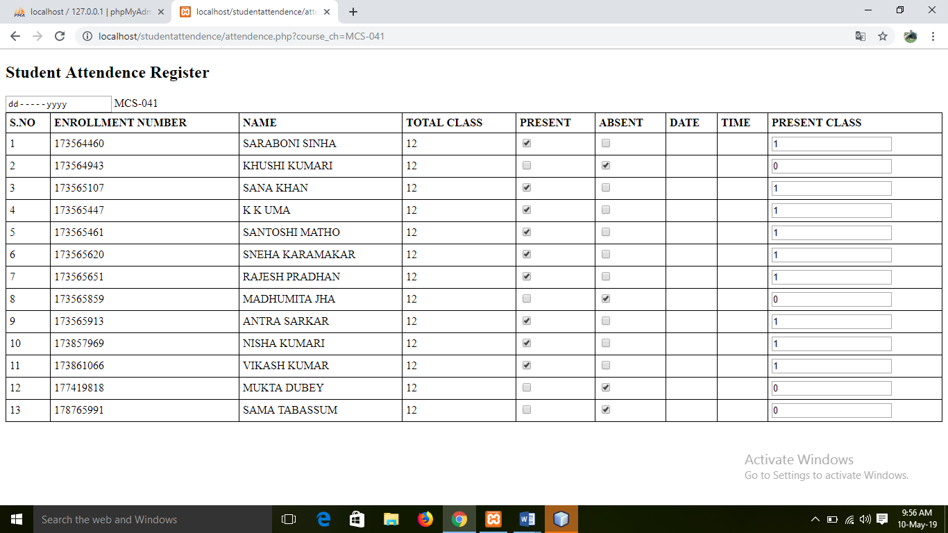

**ASSIGNMENT SUBMISSION MODULE**

**STUDENT REGISTRATION PAGE:**

<?php

ob_start();

session_start();

?>

<!DOCTYPE html>

<html>

<head>

<meta name="viewport" content="width=device-width, initial-scale=1">

<link rel="stylesheet" href="css/stud_reg.css">

</head>

<body style="background-color:#FEF5E7;">

<a href="index.php"><?php echo '<< Back To Home ';?> </a>

<form action="regwork.php" method="POST">

<div class="container" style="width:60%;">

<h1>Student Registration Form</h1>

<p>Fill in this form for enrollment.</p>

<span style="color:greenyellow;"> <?php

if(isset($_SESSION['message'])){

echo $_SESSION['message'];

unset($_SESSION['message']);

}

?></span>

<hr>

<label for="username"><b>Name</b></label>

<input type="text" placeholder="Enter Student Name" name="name" required>

<label for="username"><b>Enroll NO.</b></label>

<input type="text" placeholder="Enter enrollment No." name="enroll_no" required>

<label for="email"><b>Programme Code</b></label>

<select name="program_code" class="form-control" id="sel1" style="width:100%;height: 50px;" required>

<option>Select Program Code</option>

<option>MCA</option>

<option>BCA</option>

<option>CIT</option>

</select>

<br><br>

<label for="email"><b>Semester Detail</b></label>

<select name="semester_detail" class="form-control" id="sel1" style="width:100%;height: 50px;" required>

<option>Select Semester</option>

<option>first semester</option>

<option>second semester</option>

<option>third semester</option>

<option>fourth semester</option>

<option>fifth semester</option>

<option>sixth semester</option>

</select>

<hr>

<button type="submit" name="reg" class="registerbtn">Register</button>

</div>

</form>

</body>

</html>

**REGISTRATION _WORK .PHP PAGE:**

<?php

ob_start();

session_start();

include 'db.php';

if (isset($_POST['reg'])) {

$query = mysqli_query($conn, "SELECT id as counter FROM enroll_student");

$sn = rand(000, 999);

$name = $_POST['name'];

$enroll_no = $_POST['enroll_no'];

$program_code = $_POST['program_code'];

$semester_detail = $_POST['semester_detail'];

$sql = "INSERT INTO `enroll_student`(sl_no, name, enroll_no, program_code, semester_detail) VALUES ('$sn','$name','$enroll_no','$program_code','$semester_detail')";

$res = mysqli_query($conn, $sql);

if ($res) {

header('Location:stud_reg.php');

$_SESSION['message'] = "you are successfully registered!!.";

} else {

}

}

?>

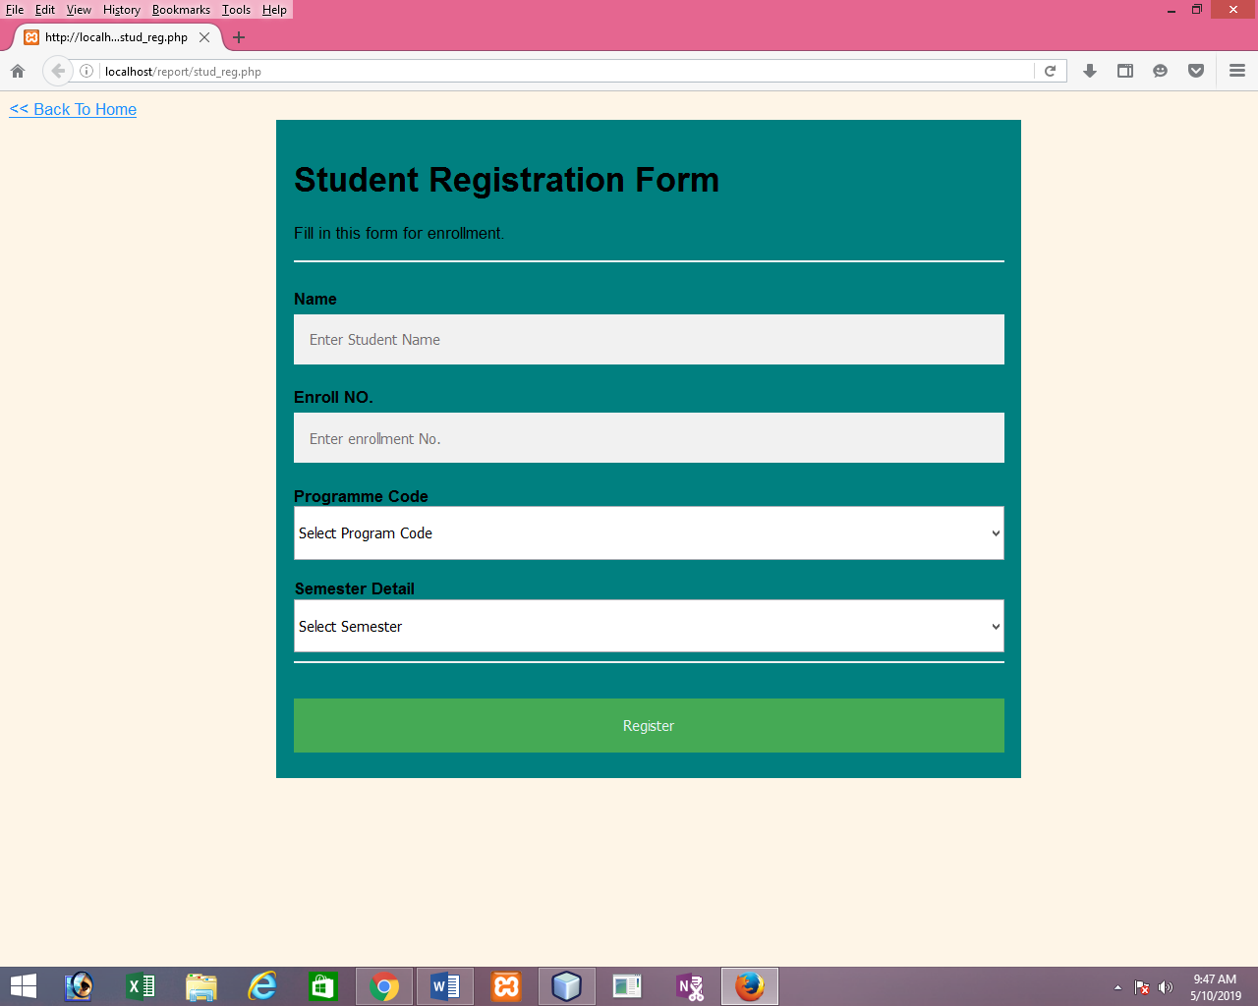

**LOGIN PAGE:**

<?php

session_start();

?>

<!DOCTYPE html>

<html>

<head>

<meta name="viewport" content="width=device-width, initial-scale=1">

<link rel="stylesheet" href="css/stud_reg.css">

</head>

<body background="img/c10.jpg">

<br><BR><BR>

<form action="login_check.php" method="POST">

<div class="container" style="width:60%;">

<h1 style="color:white;">IGNOU.</h1>

<h1>Log In..</h1>

<p>Please fill in this form to open an account.</p>

<span style="color:red;"><?php

if (isset($_SESSION['message'])) {

echo $_SESSION['message'];

}

unset($_SESSION['message']);

?></span>

<hr>

<label for="email"><b>User Name</b></label>

<input type="text" placeholder="Enter Username" name="uname" required>

<label for="psw"><b>Password</b></label>

<input type="password" placeholder="Enter Password" name="password" required>

<hr>

<p>By creating an account you agree to our <a href="#">Terms & Privacy</a>.</p>

<button type="submit" name="login" class="registerbtn">Sign In</button>

</div>

<div class="container signin " style="width:60%;">

<p>Click here for new registration?<a href="admin_reg.php">Registration</a>.</p>

</div>

</form>

</body>

</html>

***LOGIN_WORK.PHP PAGE:***

<?php

ob_start();

session_start();

include 'db.php';

if(isset($_POST['login'])){

$uname =$_POST['uname'];

$password=$_POST['password'];

$password= mysqli_real_escape_string($conn,$password);

$password=htmlentities($password);

$sql="SELECT password FROM admin where uname='$uname'";

$res= mysqli_query($conn, $sql);

$row= mysqli_fetch_assoc($res);

$pass=$row['password'];

if(password_verify($password,$pass)){

$_SESSION['uname']=$uname;

header('Location:home.php');

}

else {

header('Location:login.php');

$_SESSION['message']='username or password wrong please check, and try again!';

}

}

?>

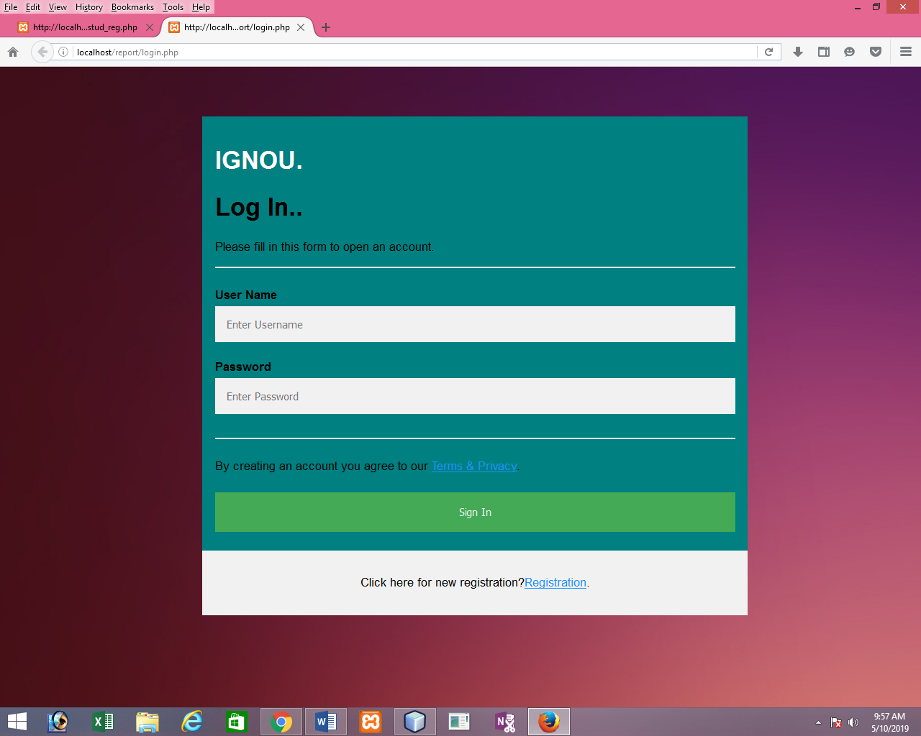

***HOME.PHP PAGE:***

<?php

include 'header.php';

?>

<!DOCTYPE html>

<html>

<body>

<div class="container-fluid" style="width:100%;height: 25px;background-color:lightgreen;">

<a href="" style="color:teal;">Home Page</a>

</div>

<br>

<br>

<div class="container" style="background-color: goldenrod;color:white;">

<h2 style="color:brown;font-family: Arial Black;">IMPORTANT LINK's</h2><br>

<div class="dropdown">

<button class="btn btn-primary dropdown-toggle text-center" type="button" data-toggle="dropdown" style="width:950px;">Select Option to Continue

<span class="caret"></span></button>

<ul class="dropdown-menu">

<li><a href="index.php" style="color:teal; width:950px;">Related Assignment </a></li>

<li><a href="#" style="color:teal; width:950px;">Related Attendance </a></li>

<li><a href="#" style="color:teal; width:950px;">Related Faculty</a></li>

</ul>

</div>

<hr>

<p style="text-align: justify;">

The Regional Centres (56), IGNOU-Army Recognised Regional Centres (6), IGNOU-Navy Recognised Regional Centres (4) and IGNOU-Assam Rifles Recognised Regional Centre (1) are responsible for the promotion of the Open University system; development, maintenance and monitoring of Study Centres and Student Support Services; and organisation of staff development programmes in the region.

How to establish (methodology)Regional Centres are established normally with cooperation and support of the respective State Governments. The perspective plan is to provide one Regional Centre for every state in the country.

Functions of Regional Centre<br>

The Regional Centre has been defined under Section 2(J) of the IGNOU Act as under: "Regional Centre" means a Centre established or maintained by the University for the purpose of coordinating and supervising the work of the Study Centres in any region and for performing such other functions as may be conferred on such Centre by the Board of Management (BoM).

Further, under Section 5(1) (XXII) of the Act, the University is empowered to confer autonomous status to a Regional Centre have been established by IGNOU to coordinate and supervise the work of the Study Centres.

Facilities Regional Centres, the sub-office of the University for all practical purposes, are also intended to act as resource centres of the University in respective regions. Regional Centres are centres for training coordinators/counsellors/other functionaries and would provide a venue for the students and the academic counsellors to express their responses with reference to a particular subject. Responsibility for random checking of student assignment, if needed, would also lie with Regional Centres. Therefore, following facilities have been provided at Regional Centres:</p>

<br>

</div><br><Br>

<style>

.footer-copyright{

padding: 20px;

background-color: black;

color:white;

}

.mb-5 a{

color: white;

margin-right: 20px;

}

</style>

<footer>

<div class="footer-copyright text-center py-3 container-fluid">© 2019 Copyright:

<a href="" style="color:skyblue;"> Ignou.Assignment.com</a>

<br><br><br>

<div class="mb-5 flex-center">

<a class="fb-ic">

<i class="fa fa-facebook-f fa-2x circle-icon" style="background:#1865A1; padding:10px;border-radius: 50%;color:white;"> </i>

</a>

<!-- Twitter -->

<a class="tw-ic">

<i class="fa fa-twitter fa-2x circle-icon" style="background:skyblue; padding:10px;border-radius: 50%;color:white;"> </i>

</a>

<!-- Google +-->

<a class="gplus-ic">

<i class="fa fa-google fa-2x circle-icon" style="background:#CD4C38 ; padding:10px;border-radius: 50%;color:white;"> </i>

</a>

<!--Linkedin -->

<a class="li-ic">

<i class="fa fa-linkedin fa-2x circle-icon" style="background:#258DA9 ; padding:10px;border-radius: 50%;color:white;"> </i>

</a>

<!--Instagram-->

<a class="ins-ic">

<i class="fa fa-instagram fa-2x circle-icon" style="background:goldenrod; padding:10px;border-radius: 50%;color:white;"> </i>

</a>

<!--Pinterest-->

<a class="pin-ic">

<i class="fa fa-pinterest fa-2x circle-icon" style="background:palevioletred; padding:10px;border-radius: 50%;color:white;"> </i>

</a>

</div>

</div>

</footer>

</body>

</html>

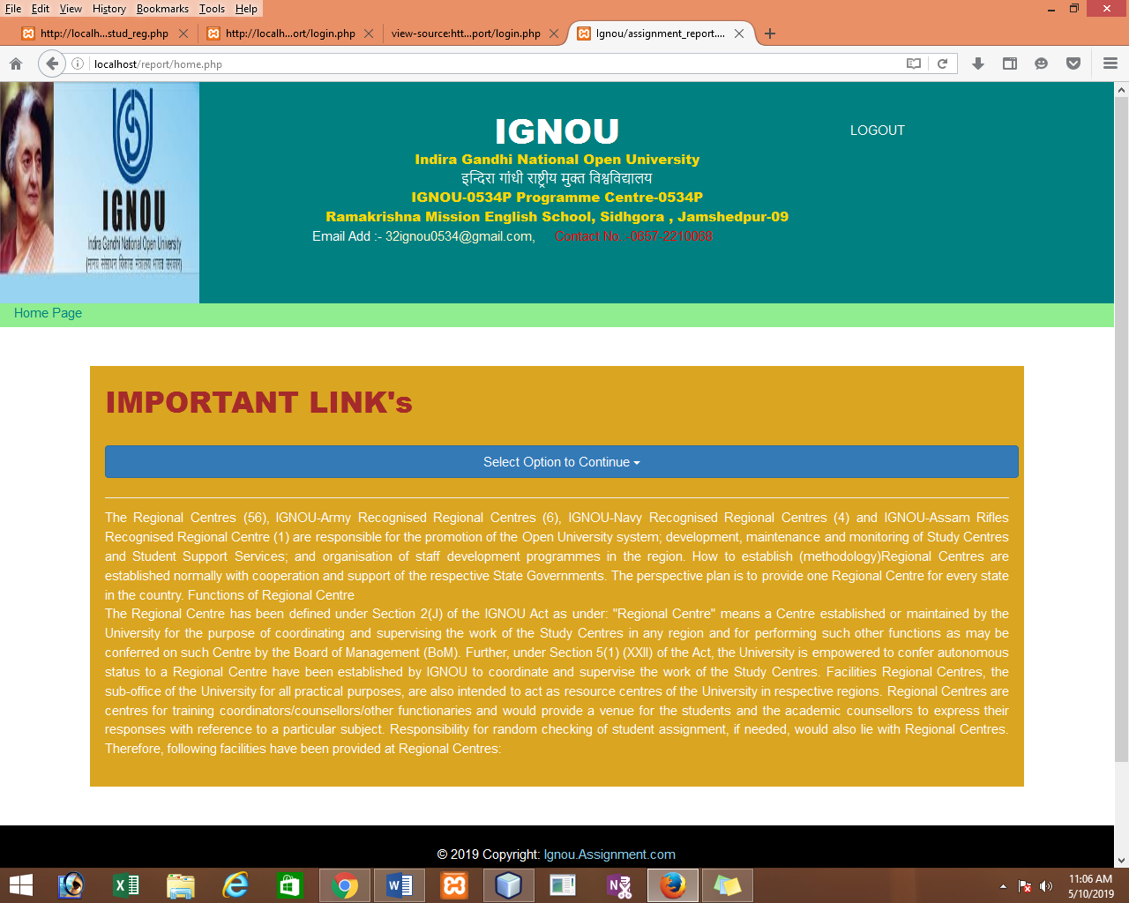

***INDEX.PHP PAGE***

<!DOCTYPE html>

<!--

To change this license header, choose License Headers in Project Properties.

To change this template file, choose Tools | Templates

and open the template in the editor.

-->

<html>

<head>

<meta charset="UTF-8">

<link rel="stylesheet" href="css/header.css">

<meta name="viewport" content="width=device-width, initial-scale=1">

<link rel="stylesheet" href="https://cdnjs.cloudflare.com/ajax/libs/font-awesome/4.7.0/css/font-awesome.min.css">

<link rel="stylesheet" href="https://maxcdn.bootstrapcdn.com/bootstrap/3.4.0/css/bootstrap.min.css">

<script src="https://ajax.googleapis.com/ajax/libs/jquery/3.3.1/jquery.min.js"></script>

<title>Ignou/assignment_report.com</title>

<style>

header{

padding:40px;

background-color: teal;

}

p{

margin-top: -10px;

}

h1{

margin-top: -10px;

}

</style>

</head>

<body style="background-color:">

<header class="container-fluid">

<div class="row">

<div class="col-sm-3">

<img src="img/logo.jpg" alt="Italian Trulli" style="width:80%;height:230px;margin-top: -40px; margin-left: -15px;margin-bottom:-40px;">

</div>

<div class="col-sm-6">

<h1 class="text-center" style="color:white;font-family: Arial Black;">IGNOU</h1>

<p class="text-center" style="font-family: Arial Black;color:gold;">Indira Gandhi National Open University</p>

<p class="text-center" style="font-family: Arial Black;color:white;">इन्दिरा गांधी राष्ट्रीय मुक्त विश्वविद्यालय </p>

<p class="text-center" style="font-family: Arial Black;color:gold;">IGNOU-0534P Programme Centre-0534P</p>

<p class="text-center" style="font-family: Arial Black;color:gold;">Ramakrishna Mission English School, Sidhgora , Jamshedpur-09</p>

<p><span style="color:white; margin-left: 20px;">Email Add :-</span> <a href="" style="color:lemonchiffon;">32ignou0534@gmail.com,</a><span style="color:red; margin-left:20px;">Contact No.:-0657-2210068</span></p>

</div>

<div class="col-sm-3">

<a href ="logout.php" class="text-right" style="color:black;margin-left:150px;margin-bottom:30px;">LOGOUT</a>

</div>

</div>

</header>

<br><br>

<a href ="logout.php">logout</a>

<div class="container">

<div class="wrapper" style="height:450px;background-color: #D1E2DF ;">

<header style="padding:20px;">

<h4 style="color:white">Assignment Submission (Programme Wise)</h4>

<hr>

</header>

<div class="card-text">

<h4>Students must be enrolled in a class(Particular Programme) to submit there theorytical assignment or practical papers.</h4>

<center> <a href="program_detail.php" class="btn btn-primary " style="background-color: teal;color:white; margin-bottom:-100px;">Assignment Submission</a></center><br><br>

<center> <a href="search_status.php" class="btn btn-primary " style="background-color: teal;color:white; margin-bottom:-100px;">Search Student Status</a></center><br><br>

<center> <a href="stud_reg.php" class="btn btn-primary " style="background-color: teal;color:white; margin-bottom:-100px;">New Registration</a></center><br><br><br><br>

<center><a style="color:blue;" class="" href="http://www.ignou.ac.in/">Go To official Website (IGNOU:http://www.ignou.ac.in/)</a></center>

</div>

</div>

</div><br>

<style>

.footer-copyright{

padding: 20px;

background-color: black;

color:white;

}

.mb-5 a{

color: white;

margin-right: 20px;

}

</style>

</head>

<body>

<footer>

<div class="footer-copyright text-center py-3 container-fluid">© 2019 Copyright:

<a href="" style="color:skyblue;"> Ignou.Assignment.com</a>

<br><br><br>

<div class="mb-5 flex-center">

<!-- Facebook -->

<a class="fb-ic">

<i class="fa fa-facebook-f fa-2x circle-icon" style="background:#1865A1; padding:10px;border-radius: 50%;color:white;"> </i>

</a>

<!-- Twitter -->

<a class="tw-ic">

<i class="fa fa-twitter fa-2x circle-icon" style="background:skyblue; padding:10px;border-radius: 50%;color:white;"> </i>

</a>

<!-- Google +-->

<a class="gplus-ic">

<i class="fa fa-google fa-2x circle-icon" style="background:#CD4C38 ; padding:10px;border-radius: 50%;color:white;"> </i>

</a>

<!--Linkedin -->

<a class="li-ic">

<i class="fa fa-linkedin fa-2x circle-icon" style="background:#258DA9 ; padding:10px;border-radius: 50%;color:white;"> </i>

</a>

<!--Instagram-->

<a class="ins-ic">

<i class="fa fa-instagram fa-2x circle-icon" style="background:goldenrod; padding:10px;border-radius: 50%;color:white;"> </i>

</a>

<!--Pinterest-->

<a class="pin-ic">

<i class="fa fa-pinterest fa-2x circle-icon" style="background:palevioletred; padding:10px;border-radius: 50%;color:white;"> </i>

</a>

</div>

</div>

</footer>

</body>

</html>

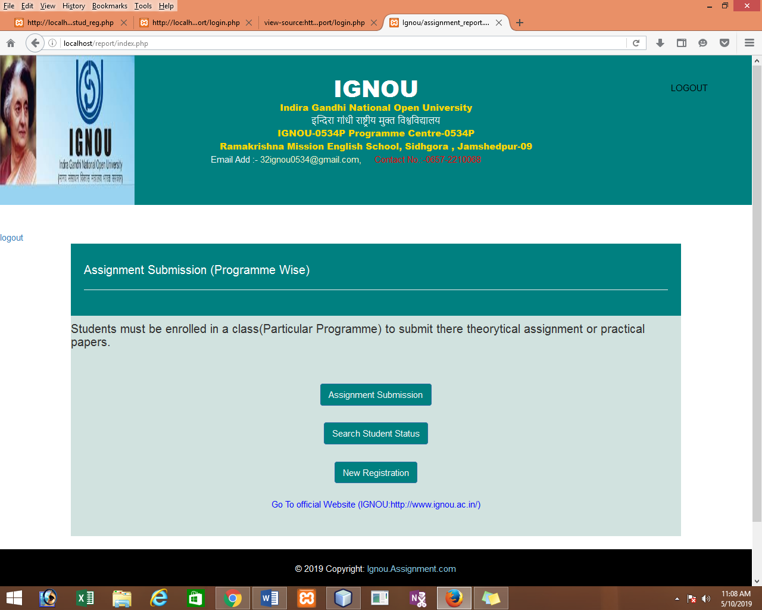

***ASSIGNMENT SUBMISSION.PHP PAGE:***

<?php

ob_start();

include 'header.php';

?>

<br>

<a href="index.php"><?php echo '<< Back ';?> </a>

<br>

<?php

session_start();

if(isset($_SESSION['message'])){

echo $_SESSION['message'];

unset($_SESSION['message']);

}

?>

<div class="container">

<div class="wrapper" style="height:450px;background-color: #D1E2DF ;">

<header style="color:white; padding:10px;">Please fill in this Form for submission of Student's Assignment According to Programme <hr></header>

<br>

<form class="container-fluid" action="course_detail.php" method="POST">

<div class="form-group">

<label for="pwd">Select Programme Code:</label>

<select name="program_code" class="form-control" id="sel1">

<option></option>

<option>MCA</option>

<option>BCA</option>

<option>CIT</option>

</select>

</div>

<label for="pwd">Select Semester:</label>

<select name="semester_detail" class="form-control" id="sel1">

<option></option>

<option>first semester</option>

<option>second semester</option>

<option>third semester</option>

<option>fourth semester</option>

<option>fifth semester</option>

<option>sixth semester</option>

</select>

<br>

<center><button type="submit" class="btn btn-default" name="submit" style='width:200px; color:teal;'>Submit</button></center>

</form>

</div>

</div>

<br><br>

<style>

.footer-copyright{

padding: 20px;

background-color: black;

color:white;

}

.mb-5 a{

color: white;

margin-right: 20px;

}

</style>

</head>

<body>

<footer>

<div class="footer-copyright text-center py-3 container-fluid">© 2019 Copyright:

<a href="" style="color:skyblue;"> Ignou.Assignment.com</a>

<br><br><br>

<div class="mb-5 flex-center">

<!-- Facebook -->

<a class="fb-ic">

<i class="fa fa-facebook-f fa-2x circle-icon" style="background:#1865A1; padding:10px;border-radius: 50%;color:white;"> </i>

</a>

<!-- Twitter -->

<a class="tw-ic">

<i class="fa fa-twitter fa-2x circle-icon" style="background:skyblue; padding:10px;border-radius: 50%;color:white;"> </i>

</a>

<!-- Google +-->

<a class="gplus-ic">

<i class="fa fa-google fa-2x circle-icon" style="background:#CD4C38 ; padding:10px;border-radius: 50%;color:white;"> </i>

</a>

<!--Linkedin -->

<a class="li-ic">

<i class="fa fa-linkedin fa-2x circle-icon" style="background:#258DA9 ; padding:10px;border-radius: 50%;color:white;"> </i>

</a>

<!--Instagram-->

<a class="ins-ic">

<i class="fa fa-instagram fa-2x circle-icon" style="background:goldenrod; padding:10px;border-radius: 50%;color:white;"> </i>

</a>

<!--Pinterest-->

<a class="pin-ic">

<i class="fa fa-pinterest fa-2x circle-icon" style="background:palevioletred; padding:10px;border-radius: 50%;color:white;"> </i>

</a>

</div>

</div>

</footer>

</div>

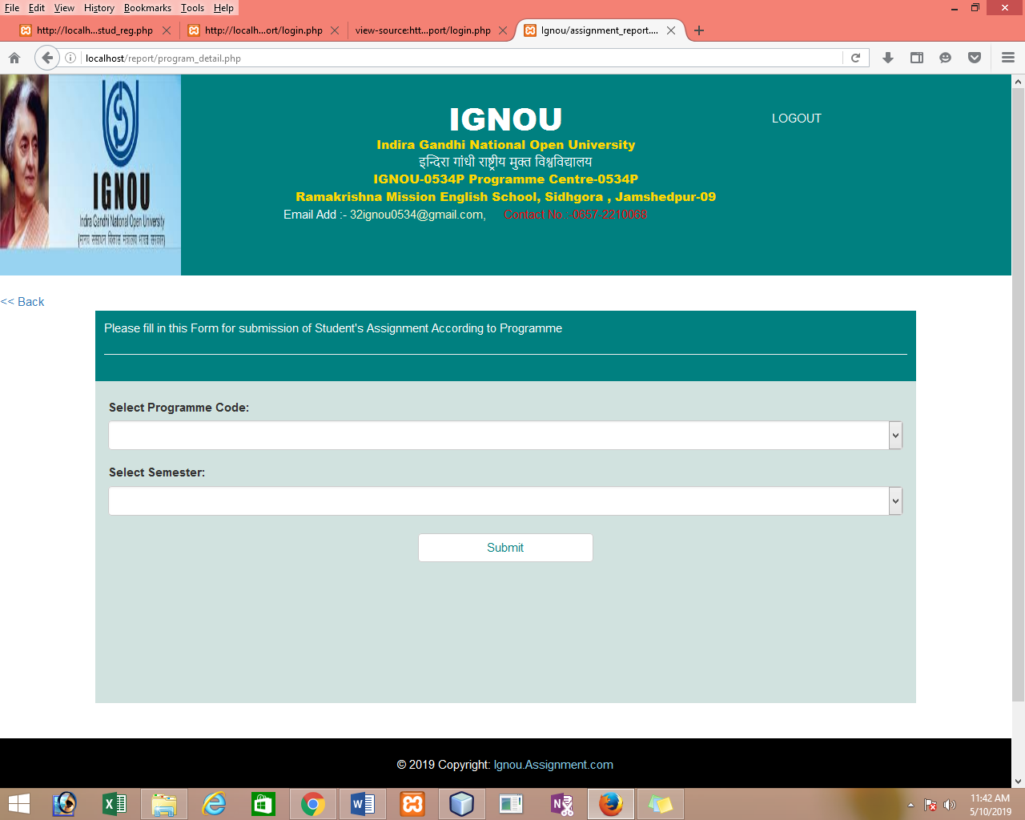

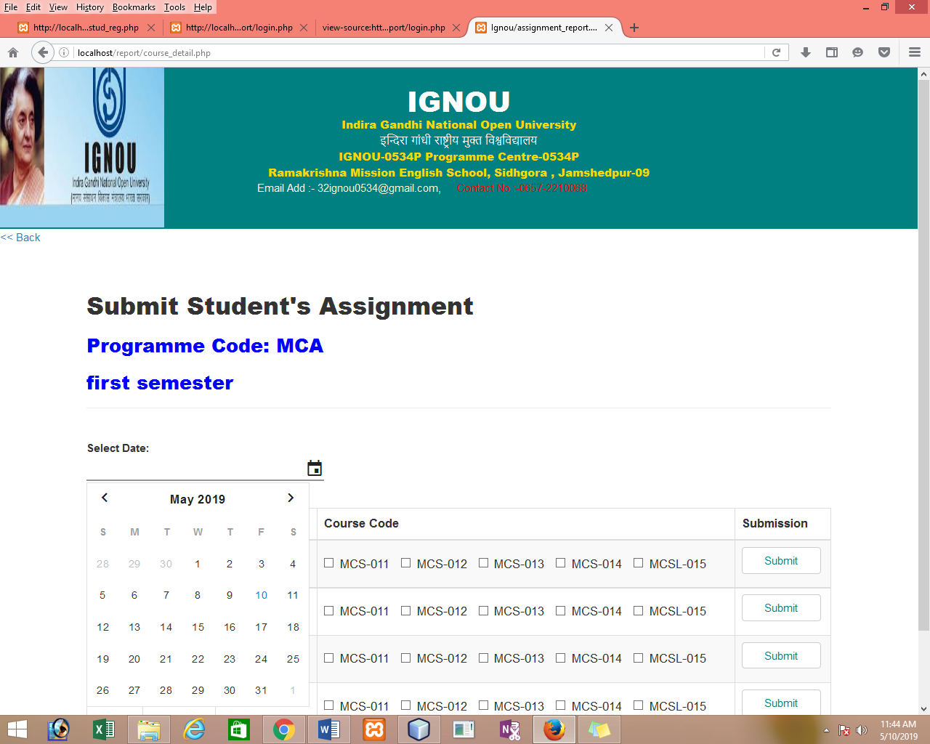

***SEARCH_STATUS.PHP PAGE:***

<?php

ob_start();

session_start();

?>

<?php

include'header.php';

?>

<!DOCTYPE html>

<html>

<head>

<meta name="viewport" content="width=device-width, initial-scale=1">

<link rel="stylesheet" href="css/stud_reg.css">

</head>

<body>

<a href="index.php" ><?php echo '<< Back To Home ';?> </a>

<?php

if(isset($_SESSION['message'])){

echo $_SESSION['message'];

unset($_SESSION['message']);

}

?>

<br>

<form action="status_report.php" method="POST">

<div class="container" style="width:60%; margin-top:50px;">

<h1 style="color:white;">STATUS</h1>

<p>Fill in this form for search Status..!</p>

<span style="color:greenyellow;">

</span>

<hr>

<label for="username"><b>Enter Enrollment no.</b></label>

<input type="text" placeholder="Enter enrollment No." name="enroll_no" required>

<button type="submit" name="search" class="registerbtn">Search</button>

</div>

</form>

<br><br>

<style>

.footer-copyright{

padding: 20px;

background-color: black;

color:white;

}

.mb-5 a{

color: white;

margin-right: 20px;

}

</style>

</head>

<body>

<footer>

<div class="footer-copyright text-center py-3 container-fluid">© 2019 Copyright:

<a href="" style="color:skyblue;"> Ignou.Assignment.com</a>

<br><br><br>

<div class="mb-5 flex-center">

<!-- Facebook -->

<a class="fb-ic">

<i class="fa fa-facebook-f fa-2x circle-icon" style="background:#1865A1; padding:10px;border-radius: 50%;color:white;"> </i>

</a>

<!-- Twitter -->

<a class="tw-ic">

<i class="fa fa-twitter fa-2x circle-icon" style="background:skyblue; padding:10px;border-radius: 50%;color:white;"> </i>

</a>

<!-- Google +-->

<a class="gplus-ic">

<i class="fa fa-google fa-2x circle-icon" style="background:#CD4C38 ; padding:10px;border-radius: 50%;color:white;"> </i>

</a>

<!--Linkedin -->

<a class="li-ic">

<i class="fa fa-linkedin fa-2x circle-icon" style="background:#258DA9 ; padding:10px;border-radius: 50%;color:white;"> </i>

</a>

<!--Instagram-->

<a class="ins-ic">

<i class="fa fa-instagram fa-2x circle-icon" style="background:goldenrod; padding:10px;border-radius: 50%;color:white;"> </i>

</a>

<!--Pinterest-->

<a class="pin-ic">

<i class="fa fa-pinterest fa-2x circle-icon" style="background:palevioletred; padding:10px;border-radius: 50%;color:white;"> </i>

</a>

</div>

</div>

</footer>

</body>

</html>

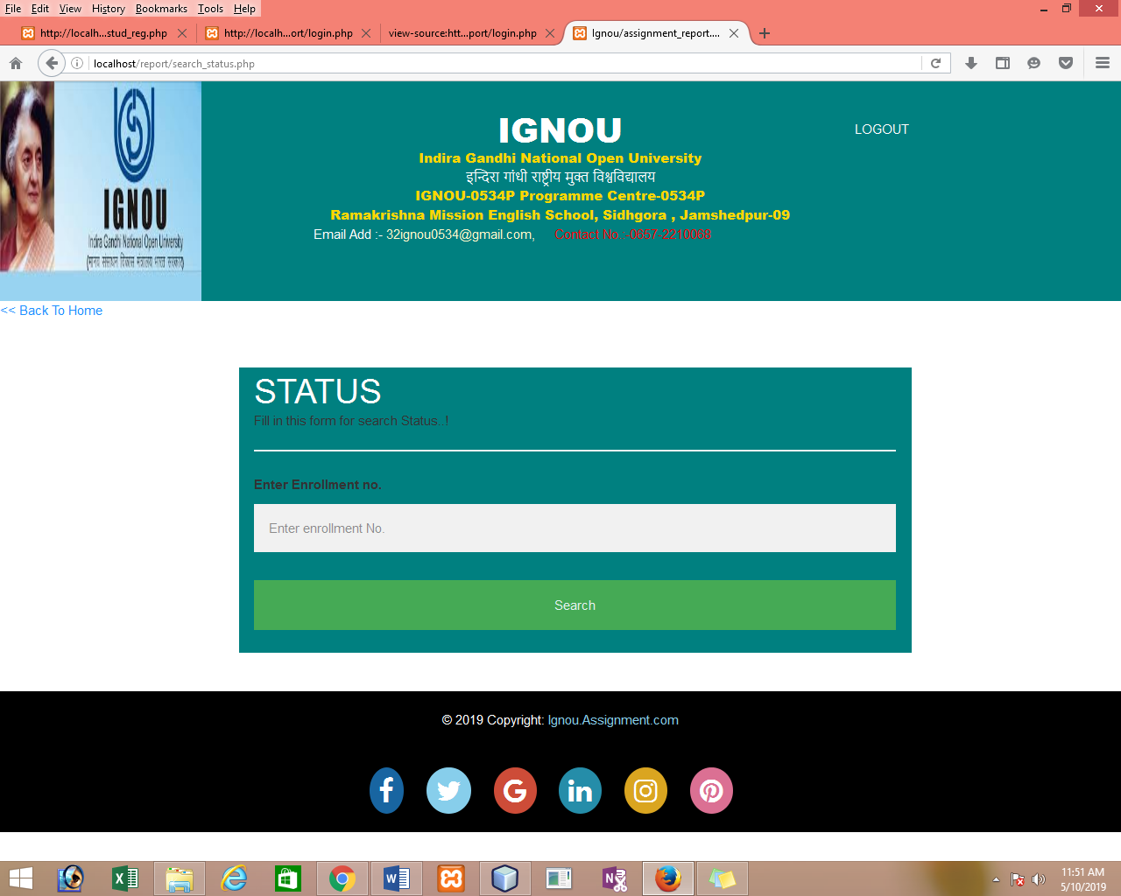

***STATUS _REPORT .PHP PAGE:***

<?php include 'header.php'; ?>

<br>

<a class="noprint" href="search_status.php"><?php echo '<<< Back'; ?></a>

<html>

<title>report of assignment submission</title>

<head>

<meta charset="UTF-8">

<meta name="viewport" content="width=device-width, initial-scale=1.0">

<link rel="stylesheet" href="css_table/bootstrap.min.css">

<link rel="stylesheet" href="css_table/dataTables.bootstrap.min.css">

</head>

<body>

<script type="text/javascript" src="jquery.js"></script>

<script type="text/javascript" src="jquery.dataTables.min.js"></script>

<script type="text/javascript" src="dataTables.bootstrap.min.js"></script>

<script type="text/javascript">

$(document).ready(function () {

$('#example').DataTable();

});

</script>

<br>

<h2 class="text-center" style="color:brown; font-family: Bernard MT Condensed;" >STATUS REPORT OF ASSIGNMENT SUBMISSION</h2>

<p class="text-center" style="color:brown; font-family: Bernard MT Condensed;">(For Student Confirmation Only)</p>

<?php

include 'db.php';

if (isset($_POST['search'])) {

$enroll_no = $_POST['enroll_no'];

$query = "select * from enroll_student where enroll_no=$enroll_no";

$res = mysqli_query($conn, $query);

$row = mysqli_fetch_assoc($res);

?>

<h5 style="color:brown; font-family: Bernard MT Condensed; margin-left: 20px;"> Name Of Student:<?php echo $row['name'] . '<br>'; ?></h5>

<h5 style="color:brown; font-family: Bernard MT Condensed; margin-left: 20px;"> Enrollment no.:<?php echo $row['enroll_no'] . '<br>'; ?></h5>

<h5 style="color:brown; font-family: Bernard MT Condensed; margin-left: 20px;"> Programme:<?php echo $row['program_code'] . '<br>'; ?></h5>

<h5 style="color:brown; font-family: Bernard MT Condensed; margin-left: 20px;"> semester : <?php echo $row['semester_detail']; ?></h5>

<?php

$sql = "select * from stud_status where enroll_no=$enroll_no";

$result = mysqli_query($conn, $sql);

$row1 = mysqli_fetch_assoc($result);

?>

<div class="container" style="margin-top: 40px;">

<table id="example" class="table table-striped table-bordered" style="width:100%">

<thead>

<tr>

<th>COURSE CODE</th>

<th>STATUS</th>

</tr>

</thead>

<tbody>

<?php

if ($row['program_code'] === 'MCA' && $row['semester_detail'] === 'first semester') {

for ($i = 1; $i <= 4; $i++) {

?>

<tr>

<td>MCS-01<?= $i ?></td>

<td>

<?php

if (strpos($row1['course_status'], 'mcs1' . $i) !== FALSE) {

echo 'Submitted';

} else {

echo 'Not Submitted';

}

?>

<td>

</tr>

<?php

}

?>

<tr>

<td>MCSL-015</td>

<td>

<?php

if (strpos($row1['course_status'], 'mcsl15') !== FALSE) {

echo 'Submitted';

} else {

echo 'Not Submitted';

}

?>

</td>

</tr>

<?php

} elseif ($row['program_code'] === 'MCA' && $row['semester_detail'] === 'second semester') {

for ($i = 1; $i <= 4; $i++) {

?>

<tr>

<td>MCS-02<?= $i ?></td>

<td>

<?php

if (strpos($row1['course_status'], 'mcs2' . $i) !== false) {

echo 'Submitted';

} else {

echo 'Not Submitted';

}

?>

</td>

</tr>

<tr>

<td>MCSL-025</td>

<td>

<?php

if (strpos($row1['course_status'], 'mcsl25') !== FALSE) {

echo 'Submitted';

} else {

echo 'Not Submitted';

}

?>

</td>

</tr>

<?php

}

} elseif ($row['program_code'] === 'MCA' && $row['semester_detail'] === 'third semester') {

for ($i = 1; $i <= 5; $i++) {

?>

<tr>

<td>MCS-03<?= $i ?></td>

<td>

<?php

if (strpos($row1['course_status'], 'mcs3' . $i) !== false) {

echo 'Submitted';

} else {

echo 'Not Submitted';

}

?>

</td>

</tr>

<?php

}

?>

<tr>

<td>MCSL-036</td>

<td>

<?php

if (strpos($row1['course_status'], 'mcsl36') !== FALSE) {

echo 'Submitted';

} else {

echo 'Not Submitted';

}

?>

</td>

</tr>

<?php

} elseif ($row['program_code'] === 'MCA' && $row['semester_detail'] === 'fourth semester') {

for ($i = 1; $i <= 4; $i++) {

<tr>

<td>MCS-04<?= $i ?></td>

<td>

<?php

if (strpos($row1['course_status'], 'mcs4' . $i) !== false) {

echo 'Submitted';

} else {

echo 'Not Submitted';

}

?>

</td>

</tr>

<tr>

<?php

}

?>

<td>MCSL-046</td>

<td>

<?php

if (strpos($row1['course_status'], 'mcsl46') !== FALSE) {

echo 'Submitted';

} else {

echo 'Not Submitted';

}

?>

</td>

</tr>

<?php

} elseif ($row['program_code'] === 'MCA' && $row['semester_detail'] === 'fifth semester') {

for ($i = 1; $i <= 4; $i++) {

?>

<tr>

<td>MCS-05<?= $i ?></td>

<td>

<?php

if (strpos($row1['course_status'], 'mcs5' . $i) !== false) {

echo 'Submitted';

} else {

echo 'Not Submitted';

}

?>

</td>

</tr>

<tr>

<td>MCSL-055</td>

<td>

<?php

if (strpos($row1['course_status'], 'mcsl55') !== FALSE) {

echo 'Submitted';

} else {

echo 'Not Submitted';

}

?>

</td>

</tr>

<?php

}

} elseif ($row['program_code'] === 'MCA' && $row['semester_detail'] === 'sixth semester') {

for ($i = 1; $i <= 1; $i++) {

?>

<tr>

<td>MCS-06<?= $i ?></td>

<td>

<?php

if (strpos($row1['course_status'], 'mcs6' . $i) !== false) {

echo 'Submitted';

} else {

echo 'Not Submitted';

}

?>

</td>

</tr>

<tr>

<td>MCSL-062</td>

<td>

<?php

if (strpos($row1['course_status'], 'mcsl62') !== FALSE) {

echo 'Submitted';

} else {

echo 'Not Submitted';

}?>

</td>

</tr>

<?php

}

}

// <!---------------------bca-------------->

elseif ($row['program_code'] === 'BCA' && $row['semester_detail'] === 'first semester') {

for ($i = 1; $i <= 5; $i++) {

?>

<tr>

<td>BCS-01<?= $i ?></td>

<td>

<?php

if (strpos($row1['course_status'], 'bcs' . $i) !== false) {

echo 'Submitted';

} else {

echo 'Not Submitted';

}

?>

</td>

</tr>

<?php

}

} elseif ($row['program_code'] === 'BCA' && $row['semester_detail'] === 'second semester') {

for ($i = 1; $i <= 5; $i++) {

?>

<tr>

<td>BCS-02<?= $i ?></td>

<td>

<?php

if (strpos($row1['course_status'], 'bcs' . $i) !== false) {

echo 'Submitted';

} else {

echo 'Not Submitted';

}

?>

</td>

</tr>

<?php

}

} elseif ($row['program_code'] === 'BCA' && $row['semester_detail'] === 'third semester') {

for ($i = 1; $i <= 5; $i++) {

?>

<tr>

<td>BCS-03<?= $i ?></td>

<td>

<?php

if (strpos($row1['course_status'], 'bcs' . $i) !== false) {

echo 'Submitted';

} else {

echo 'Not Submitted';

}

?>

</td>

</tr>

<?php

}

} elseif ($row['program_code'] === 'BCA' && $row['semester_detail'] === 'fourth semester') {

for ($i = 1; $i <= 3; $i++) {

?>

<tr>

<td>BCS-04<?= $i ?></td>

<td>

<?php

if (strpos($row1['course_status'], 'bcs' . $i) !== false) {

echo 'Submitted';

} else {

echo 'Not Submitted';

}

?>

</td>

</tr>

<?php

}

} elseif ($row['program_code'] === 'BCA' && $row['semester_detail'] === 'fifth semester') {

for ($i = 1; $i <= 3; $i++) {

?>

<tr>

<td>BCS-05<?= $i ?></td>

<td>

<?php

if (strpos($row1['course_status'], 'bcs' . $i) !== false) {

echo 'Submitted';

} else {

echo 'Not Submitted';

}

?>

</td>

</tr>

<?php

}

} elseif ($row['program_code'] === 'BCA' && $row['semester_detail'] === 'sixth semester') {

?>

<tr>

<td>BCSl-061</td>

<td>

<?php

if (strpos($row1['course_status'], 'bcsl61') !== FALSE) {

echo 'Submitted';

} else {

echo 'Not Submitted';

?>

</td>

</tr>

<?php

}

//<!----------FOR CIT BRANCH-------------->

elseif ($row['program_code'] === 'CIT' && $row['semester_detail'] === 'first semester') {

for ($i = 1; $i <= 5; $i++) {

?>

<tr>

<td>CIT-01<?= $i ?></td>

<td>

<?php

if (strpos($row1['course_status'], 'cit' . $i) !== FALSE) {

echo 'Submitted';

} else {

echo 'Not Submitted';

}

?>

</td>

</tr>

<?php

}

?>

<?php

} elseif ($row['program_code'] === 'CIT' && $row['semester_detail'] === 'second semester') {

for ($i = 1; $i <= 5; $i++) {

?>

<tr>

<td>CIT-02<?= $i ?></td>

<td>

<?php

if (strpos($row1['course_status'], 'cit' . $i) !== FALSE) {

echo 'Submitted';

} else {

echo 'Not Submitted';

} ?>

</td>

</tr>

<?php

}

?>

<?php

} elseif ($row['program_code'] === 'CIT' && $row['semester_detail'] === 'third semester') {

for ($i = 1; $i <= 5; $i++) {

?>

<tr>

<td>CIT-03<?= $i ?></td>

<td>

<?php

if (strpos($row1['course_status'], 'cit' . $i) !== FALSE) {

echo 'Submitted';

} else {

echo 'Not Submitted';

}

?>

</td>

</tr>

<?php

}

?>

<?php

} elseif ($row['program_code'] === 'CIT' && $row['semester_detail'] === 'fourth semester') {

for ($i = 1; $i <= 5; $i++) {

?>

<tr>

<td>CIT-04<?= $i ?></td>

<td>

<?php

if (strpos($row1['course_status'], 'cit' . $i) !== FALSE) {

echo 'Submitted';

} else {

echo 'Not Submitted';

}

?>

</td>

</tr>

<?php

}

?>

<?php

} elseif ($row['program_code'] === 'CIT' && $row['semester_detail'] === 'fifth semester') {

for ($i = 1; $i <= 2; $i++) {

?>

<tr>

<td>CIT-05<?= $i ?></td>

<td>

<?php

if (strpos($row1['course_status'], 'cit' . $i) !== FALSE) {

echo 'Submitted';

} else {

echo 'Not Submitted';

}

?>

</td>

</tr>

<?php

}

?>

<?php

} elseif ($row['program_code'] === 'CIT' && $row['semester_detail'] === 'sixth semester') {

for ($i = 1; $i <= 2; $i++) {

?>

<tr>

<td>CIT-06<?= $i ?></td>

<td>

<?php

if (strpos($row1['course_status'], 'cit' . $i) !== FALSE) {

echo 'Submitted';

} else {

echo 'Not Submitted';

}

?>

</td>

</tr>

<?php

}

?>

<?php

}

}

?>

</tbody>

</table>

</div>

<script>

function myFunction() {

window.print();

}

</script>

<!--<script>

$(document).ready(function(){

$("#hide").click(function(){

$("#header").hide();

});

});

</script>-->

<center><button class=" btn btn-primary text-center" style="background-color: teal;color: white;width:140px;" onclick="myFunction()">Print Status </button></center>

</body>

</html>

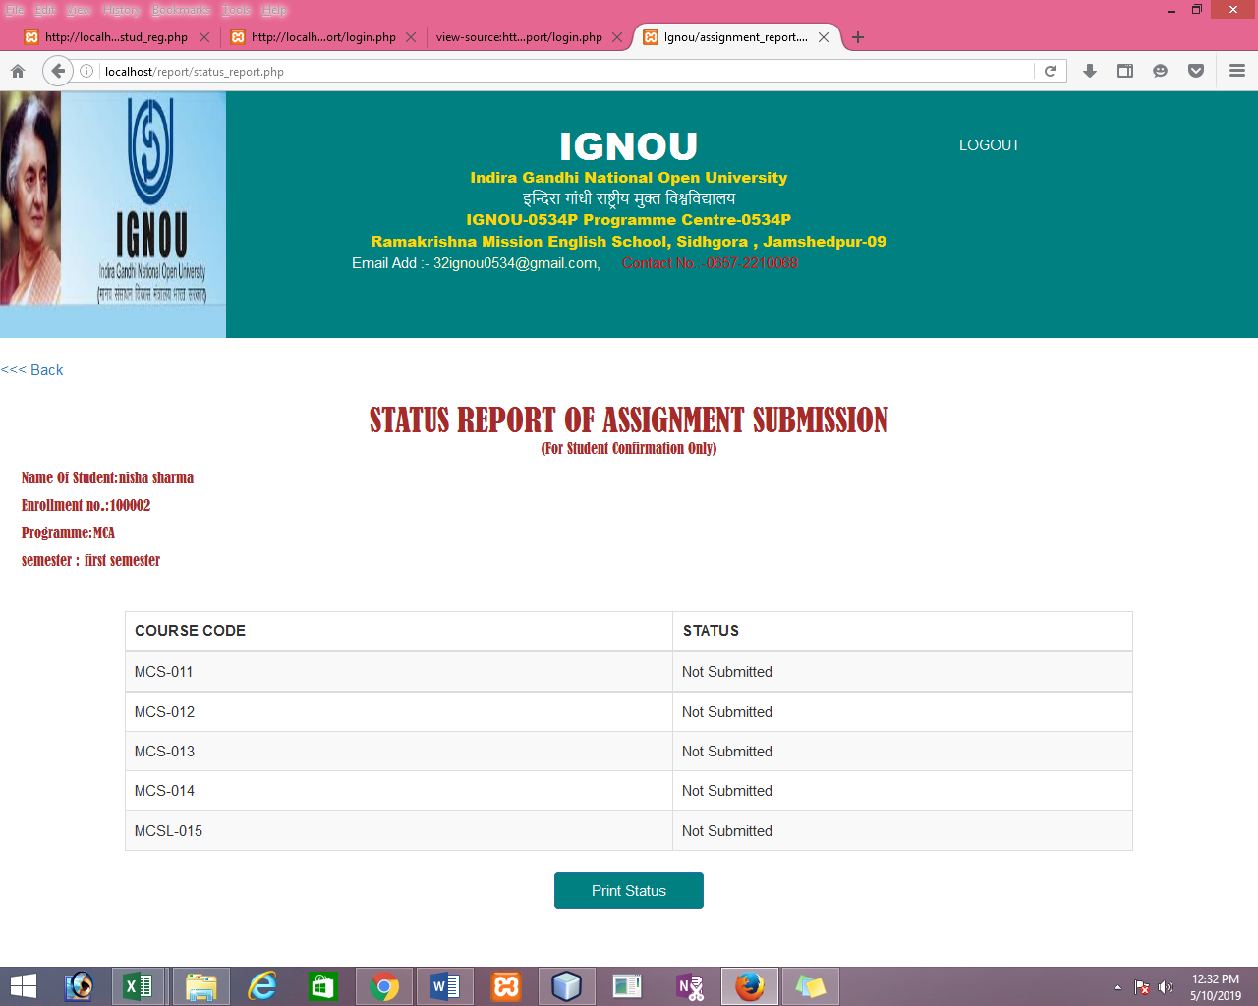

**LOGOUT .PHP PAGE :**

<?php

ob_start();

session_start();

if(isset($_SESSION['uname']))

{

unset($_SESSION['uname']);

session_destroy();

header("Location: login.php");

}

else{

header("Location:home.php");

}

?>

**FACULTY MODULE**

**FACULTY MAIN PAGE:**

<?php

$conn=mysqli_connect("localhost","root","","faculty");

$sql="select * from regis";

$res=mysqli_query($conn,$sql);

?>

<html>

<title>Faculty</title>

<head>

<style>

table, td, th {

border:; ;

}

table {

border-collapse: collapse;

width: 70%;

font-size: 24;

}

th {

height: 50px;

}

</style>

</head>

<body bgcolor="teal" text="white">

<table style="margin-top:-5px;width:100%;">

<tr><th colspan="6"><img src="logo.jpg" style="margin-left:px;margin- right:px;width:100%;height:150px;"> </tr>

<tr>

<th colspan=" "><a href="Registration form.php">New Registration for faculty</a></th>

<th></th>

<th><a href="fupdate.php">Update</a></th>

<th></th>

<th><a href="fupdate.php">Delete</a></th>

<th></th>

<th><a href="fupdate.php">Search</a></th>

</tr>

<?php

echo "<table class='table table-hover' border='1' style='width:100%;'><tr><th>Faculty ID</th><th>Faculty Name</th><th>Address</th><th>Phone.NO</th><th>Email</th><th>Qualification</th><t>experience</th></tr>";

while($row=mysqli_fetch_array($res))

{

echo "<tr><td>$row[0]</td><td>$row[1]</td><td>$row[2]</td><td>$row[3]</td><td>$row[4]</td><td>$row[5]</td><td>$row[6]</td></tr>";

}

?>

</table>

</body>

</html>

**FACULTY MAIN PAGE**

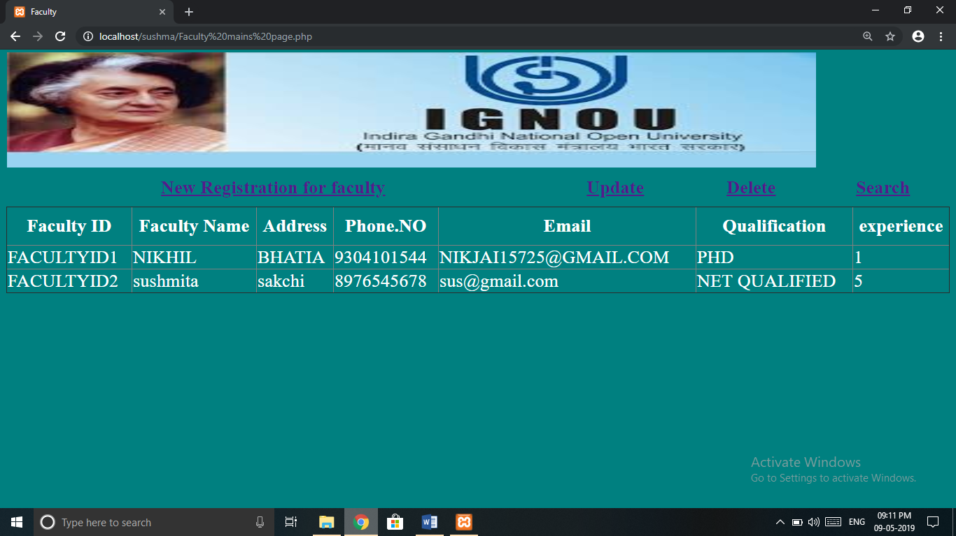

**REGISTRATION FORM:**

<?php

error_reporting(0);

$c=1;

if(isset($_POST['sub']))

{

$name=$_POST['name'];

$add=$_POST['add'];

$pno=$_POST['pno'];

$email=$_POST['email'];

$quali=$_POST['s1'];

$exp=$_POST['s2'];

$conn=mysqli_connect("localhost","root","","faculty");

$sql="select * from regis";

$res= mysqli_query($conn,$sql);

while($row=mysqli_fetch_assoc($res))

{ $c=$c+1;}

$fid="FACULTYID".(string)$c;

$conn=mysqli_connect("localhost","root","","faculty");

$sql1="insert into regis (fid, name, Address, phone_no, email, qualification, experience,BCA1 , BCA2,BCA3,BCA4,BCA5,BCA6,MCA1,MCA2,MCA3,MCA4,MCA5,MCA6) values ('".$fid."','".$name."','".$add."', '".$pno."','".$email."', '".$quali."','".$exp."','".$_POST['n1']."', '".$_POST['n2']."','".$_POST['n3']."','".$_POST['n4']."','".$_POST['n5']."', '".$_POST['n6']."',

'".$_POST['n7']."' ,'".$_POST['n8']."','".$_POST['n9']."','".$_POST['n10']."' ,'".$_POST['n11']."', '".$_POST['n12']."')";

mysqli_query($conn,$sql1);

echo "<script>alert('faculty id $fid');</script>";

}

?>

<html>

<head>

<title> Registration Form </title>

</head>

<script>

function ok()

{

var x=confirm("are you sure");

if(x==true)

{

return true;

}

else

{

return false;

}

}

</script>

<body bgcolor="teal" text="white">

<pre> <form method ="post" action="" onsubmit="return ok()">

<font size= 5><b><H1><u> New Registration for Faculty </u></H1></font>

<font size=5> Name : <input type="text" Name="name" size="50" ><br></font>

<font size=5> Address : <input type="text" Name="add" size="50" ><br></font>

<font size=5> Contact number : <input type="text" Name="pno" size="50"><br></font>

<font size=5> E-mail ID : <input type="text" Name="email" size="50"/><br></font>

<font size=5> Qualification : <select name="s1" style="width:29%;">

<option value="others">others</option>

<option value="Post graduate diploma in computer application"> Post graduate diploma in computer application</option>

<option value="MCA">MCA</option>

<option value="PHD">PHD</option>

<option value="NET QUALIFIED">NET QUALIFIED</option>

<br></select><br>

<font size=5> Experience : <select name="s2" style="width:29%;">

<option value=1>1</option>

<option value=2>2</option>

<option value=3>3</option>

<option value=4>4</option>

<option value=5>5</option>

<option value=6>6</option>

<option value=7>7</option>

<option value=8>8</option>

<option value=9>9</option>

<option value=10>10</option>

<option value=11>11</option>

<option value=11>11</option>

<option value=12>12</option>

<option value=13>13</option>

<option value=14>14</option>

<option value=15>15</option>

<option value="fresher">fresher</option>

</select>

</font></pre></b><br>

<b> classes alloted: </b><br>

<input type="checkbox" name="n1" value="BCA1" id="m1" > BCA1

<input type="checkbox" name="n2" value="BCA2" id="m2" > BCA2

<input type="checkbox" name="n3" value="BCA3" id="m3" > BCA3

<input type="checkbox" name="n4" value="BCA4" id="m4" > BCA4

<input type="checkbox" name="n5" value="BCA5" id="m5" > BCA5

<input type="checkbox" name="n6" value="BCA6" id="m6" > BCA6<br>

<input type="checkbox" name="n7" value="MCA1"> MCA1

<input type="checkbox" name="n8" value="MCA2">

<input type="checkbox" name="n9" value="MCA3"> MCA3

<input type="checkbox" name="n10" value="MCA4"> MCA4

<input type="checkbox" name="n11" value="MCA5"> MCA5

<input type="checkbox" name="n12" value="MCA6"> MCA6

<br>

<center>

<input type="submit" value="SUBMIT" name="sub" onclick="chk();">

<input type="Reset" Value="RESET">

</center>

<a href="Faculty mains page.php">BACK</a>

<h2 align="center"> THANKS FOR VISITING!!!</h2>

</form>

</body>

</html>

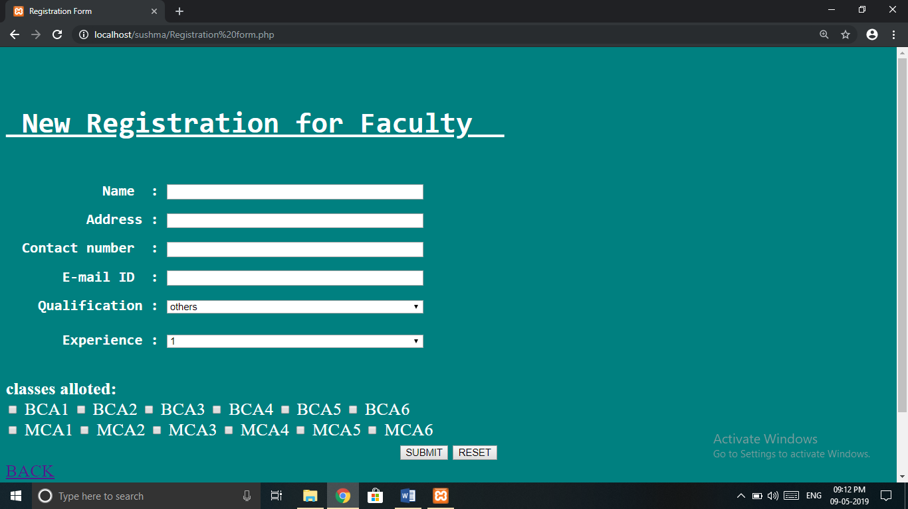

**FACULTY UPDATE DELETE SEARCH PAGE:**

<?php

error_reporting(0);

if(isset($_POST['sub']))

{

$fid=$_POST['f1'];

//echo $fid;

$name=$_POST['name'];

//echo $name;

$add=$_POST['add'];

$pno=$_POST['pno'];

$email=$_POST['email'];

$quali=$_POST['s1'];

$exp=$_POST['s2'];

$conn=mysqli_connect("localhost","root","","faculty");

$sql1="update regis set name='".$name."',Address='".$add."',phone_no='".$pno."',email='".$email."',

qualification='".$quali."',experience='".$exp."',BCA1='".$_POST['n1']."',BCA2='".$_POST['n2']."',BCA3='".$_POST['n3']."',BCA4='".$_POST['n4']."',BCA5='".$_POST['n5']."',BCA6='".$_POST['n6']."',MCA1='".$_POST['n7']."',MCA2='".$_POST['n8']."',MCA3='".$_POST['n9']."',MCA4='".$_POST['n10']."',MCA5='".$_POST['n11']."',MCA6='".$_POST['n12']."'

where fid='$fid'";

mysqli_query($conn,$sql1);

echo "<script>alert('update suucessfully');</script>";

}

?>

<?php

error_reporting(0);

$conn=mysqli_connect("localhost","root","","faculty");

if(isset($_POST['s1']))

{

$fid=$_POST['fid'];

$conn=mysqli_connect("localhost","root","","faculty");

$sql="select * from regis where fid='$fid'";

$res=mysqli_query($conn,$sql);

$row=mysqli_fetch_array($res);

//$row[7];

}

?>

<?php

$conn=mysqli_connect("localhost","root","","faculty");

if(isset($_POST['s2']))

{

$fid=$_POST['fid'];

$conn=mysqli_connect("localhost","root","","faculty");

$sql="delete from regis where fid='$fid'";

$res=mysqli_query($conn,$sql);

$row=mysqli_fetch_array($res);

//$row[7];

}

?>

<html>

<head>

<title> Registration Form </title>

</head>

<script>

function del()

{

var x=confirm("are you sure");

if(x==true)

{

return true;

}

else

{

return false;

}

}

</script>

<script>

function ok()

{

var x=confirm("are you sure");

if(x==true)

{

return true;

}

else

{

return false;

}

}

</script>

<body bgcolor="teal" text="white">

<form method ="post" action="" >

<pre> <font size=5> Faculty ID : <input type="text" Name="fid" size="50" > <br></font>

<span> <input type="submit" value="search" name="s1" style="margin-left:20%;float:left;"> </span></form>

<form method ="post" action="" onsubmit="return del()">

<font size=5> Faculty ID : <input type="text" Name="fid" size="50" ><br></font>

<span> <input type="submit" value="Delete" name="s2" style="margin left:20% ;float: left;" > </span> </pre> </form>

<form method ="post" action="" onsubmit="return ok()" style="margin-top:-50px;">

<pre> <font size=5><b><H2><u> UPDATE </u></H1></font>

<font size=5> fid : <input type="text" Name="f1" size="50" value=<?php echo $row[0];?>><br></font>

<font size=5> Name : <input type="text" Name="name" size="50" value=<?php echo $row[1];?>><br></font>

<font size=5> Address : <input type="text" Name="add" size="50" value=<?php echo $row[2];?>><br></font>

<font size=5> Contact number : <input type="text" Name="pno" size="50" value=<?php echo $row[3];?>><br></font>

<font size=5> E-mail ID : <input type="text" Name="email" size="50" value=<?php echo $row[4];?>><br></font>

<font size=5> Qualification : <select name="s1" style="width:29%;">

<option ><?php echo $row[5];?></option>

<option value="Post graduate diploma in computer application"> Post graduate diploma in computer application</option>

<option value="MCA">MCA</option>

<option value="PHD">PHD</option>

<option value="NET QUALIFIED">NET QUALIFIED</option>

</select><br>

<font size=5> Experience : <select name="s2" style="width:29%;">

<option ><?php echo $row[6];?></option>

<option value=1>1</option>

<option value=2>2</option>

<option value=3>3</option>

<option value=4>4</option>

<option value=5>5</option>

<option value=6>6</option>

<option value=7>7</option>

<option value=8>8</option>

<option value=9>9</option>

<option value=10>10</option>

<option value=11>11</option>

<option value=12>12</option>

<option value=13>13</option>

<option value=14>14</option>

<option value=15>15</option>

<option value=7>16</option>

<option value=10>17</option>

<option value="fresher">fresher</option>

</select>

</font></pre></b>

<b> classes: </b><br>

<input type="checkbox" name="n1" value="BCA1" id="m1" > BCA1

<input type="checkbox" name="n2" value="BCA2" id="m2" > BCA2

<input type="checkbox" name="n3" value="BCA3" id="m3" > BCA3

<input type="checkbox" name="n4" value="BCA4" id="m4" > BCA4

<input type="checkbox" name="n5" value="BCA5" id="m5" > BCA5

<input type="checkbox" name="n6" value="BCA6" id="m6" > BCA6<br>

<input type="checkbox" name="n7" value="MCA1" id="m7"> MCA1

<input type="checkbox" name="n8" value="MCA2" id="m8"> MCA2

<input type="checkbox" name="n9" value="MCA3" id="m9"> MCA3

<input type="checkbox" name="n10" value="MCA4" id="m10"> MCA4

<input type="checkbox" name="n11" value="MCA5" id="m11"> MCA5

<input type="checkbox" name="n12" value="MCA6" id="m12"> MCA6 <br>

<center> <input type="submit" value="UPDATE" name="sub">

<input type="Reset" Value="RESET"></center>

<a href="Faculty mains page.php">BACK</a>

<h2 align="center"> THANKS FOR VISITING!!!</h2>

</form>

</body>

<script>

var x1="<?php echo $row[7] ?>"

var x2="<?php echo $row[8] ?>"

var x3="<?php echo $row[9] ?>"

var x4="<?php echo $row[10] ?>"

var x5="<?php echo $row[11] ?>"

var x6="<?php echo $row[12] ?>"

var x7="<?php echo $row[13] ?>"

var x8="<?php echo $row[14] ?>"

var x9="<?php echo $row[15] ?>"

var x10="<?php echo $row[16] ?>"

var x11="<?php echo $row[17] ?>"

var x12="<?php echo $row[18] ?>"

if(x1=="BCA1")

{

document.getElementById("m1").checked=true;

}

if(x2=="BCA2")

{

document.getElementById("m2").checked=true;

}

if(x3=="BCA3")

{

document.getElementById("m3").checked=true;

}

if(x4=="BCA4")

{

document.getElementById("m4").checked=true;

}

if(x5=="BCA5")

{

document.getElementById("m5").checked=true;

}

if(x6=="BCA6")

{

document.getElementById("m6").checked=true;

}

if(x7=="MCA1")

{

document.getElementById("m7").checked=true;

}

if(x8=="MCA2")

{

document.getElementById("m8").checked=true;

}

if(x9=="MCA3")

{

document.getElementById("m9").checked=true;

}

if(x10=="MCA4")

{

document.getElementById("m10").checked=true;

}

if(x11=="MCA5")

{

document.getElementById("m11").checked=true;

}

if(x12=="MCA6")

{

document.getElementById("m12").checked=true;

}

</script> </html>

**FACULTY UPDATE DELETE SEARCH PAGE:**

